

CAPSTONE PROJECT REPORT
Report 4 – Software Design Document

– Ho Chi Minh, September 2026 –

Table of Contents
I. Record of Changes 3
II. Software Design Document 4
1. System Design 4
1.1 System Architecture 4
1.2 Package Diagram 4
2. Database Design 4
3. Detailed Design 5
3.1 <Feature/Function Name1> 5
3.2 <Feature/Function Name2> 6

I. Record of Changes
Date | A*  M, D | In charge | Change Description
28/09/2026 | A | Nguyễn Thành Trung | 1.1 System Architecture  1.2 Package Diagram (Backend Package Diagram and descriptions )
28/10/2026 | A | Nguyễn Thành Trung | 1.2 Package Diagram (OCR Service Diagram and descriptions)
28/10/2026 | M | Nguyễn Thành Trung | 1.1 System Architecture
28/10/2026 | A | Nguyễn Thành Trung | 3.7.1 Class Diagram  3.7.2 Sequence diagram: Bulk Upload Images  3.7.3 Sequence diagram: Photo OCR Recognition  3.7.4 Sequence diagram: Review BIB and Publish  3.7.5 Sequence diagram: Search BIB and dispute
29/10/2026 | M | Nguyễn Thành Trung | 3.7.2 Sequence diagram: Bulk Upload Images  3.7.3 Sequence diagram: Photo OCR Recognition  3.7.4 Sequence diagram: Review BIB and Publish
30/10/2026 | M | Nguyễn Thành Trung | 3.7.5 Sequence diagram: Search BIB and dispute
30/10/2026 | A | Võ Trường Phú | 3.2.2 Sequence diagram:Create Event  3.2.3 Sequence diagram:Update Event  3.2.4 Sequence diagram:Publish Event  3.6.2 Sequence diagram:Record Finish Time  3.6.3 Sequence diagram:Generate Leaderboard  3.6.4 Sequence diagram:Generate Certificate  3.10.2 Sequence diagram:Approve Organizer  3.10.3 Sequence diagram:Approve Event  3.10.4 Sequence diagram:Publish Event
30/10/2026 | A | Phạm Tiến Dũng | 3.3.1 Class Diagram  3.3.2 Sequence diagram: Register For Event  3.3.3 Sequence diagram:Process PayOS Payment  3.4.1 Class Diagram  3.4.2 Sequence diagram: QR Code & Check-in
*A - Added M - Modified D - Deleted

II. Software Design Document

1. System Design

1.1 System Architecture
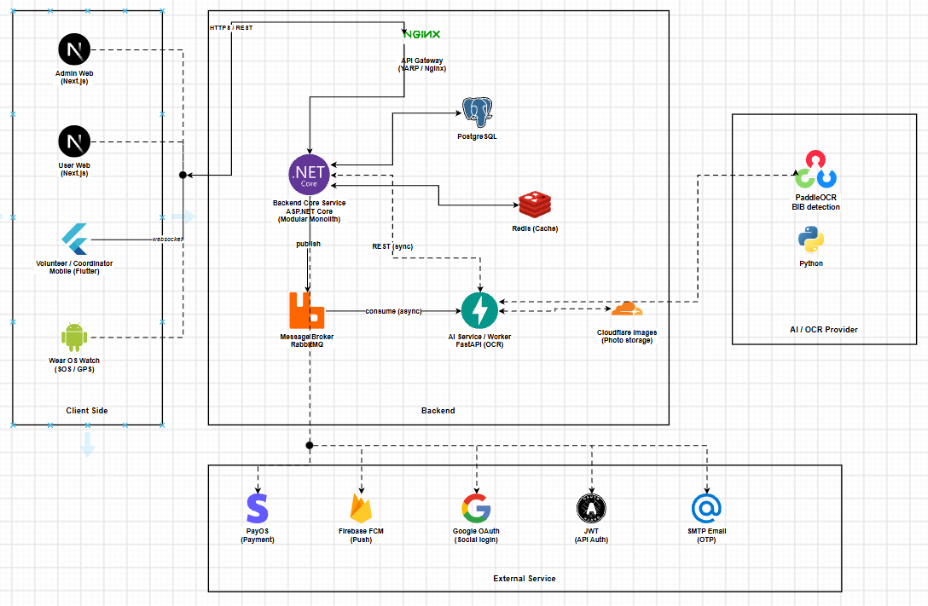
Figure 1.1.1 - System Architecture

1.2 Package Diagram
1.2.1 OCR Service Package Diagram
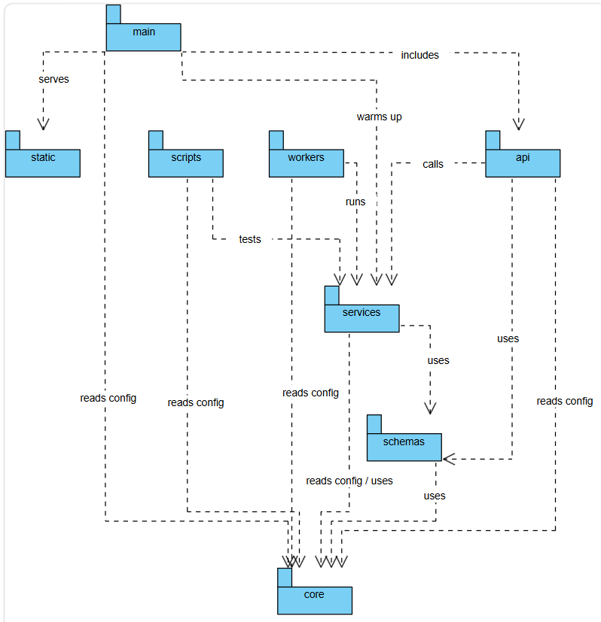
Figure 1.2.1 - OCR Service Package Diagram

1.2.2 Backend Package Diagram
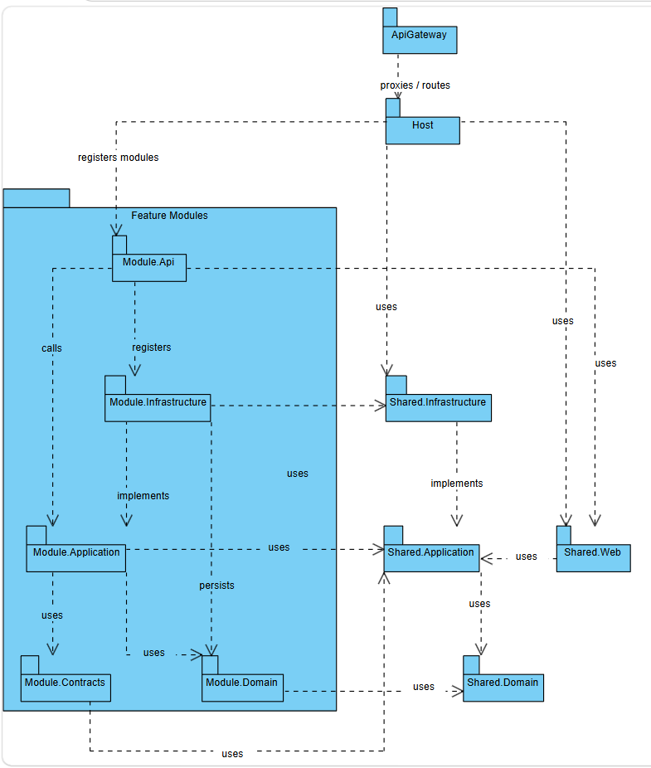
Figure 1.2.2 - Backend Package Diagram

1.2.3 Frontend Package Diagram
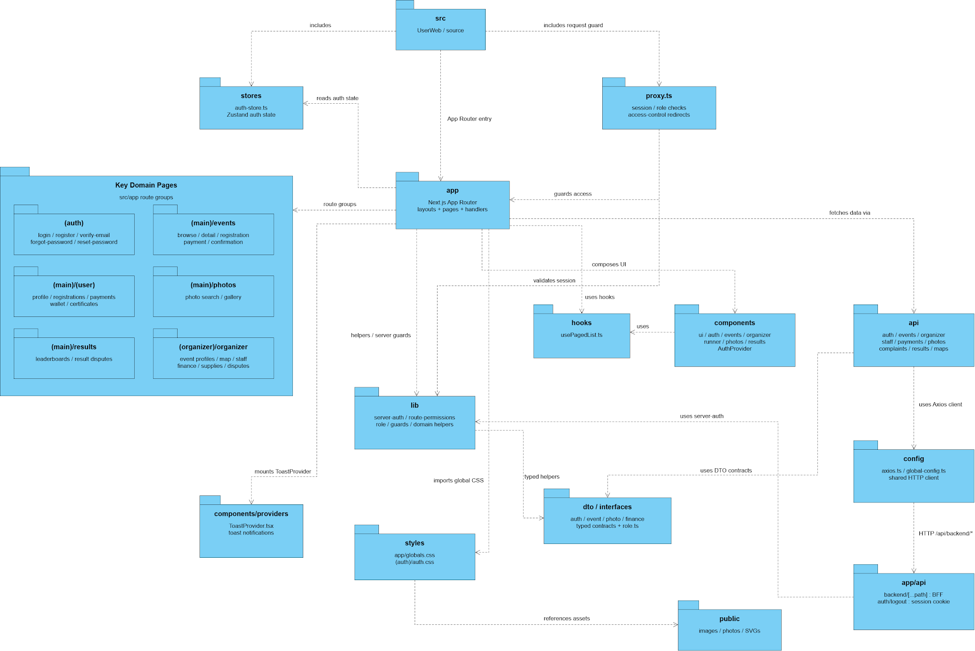
Figure 1.2.3.1 - User Web Package Diagram
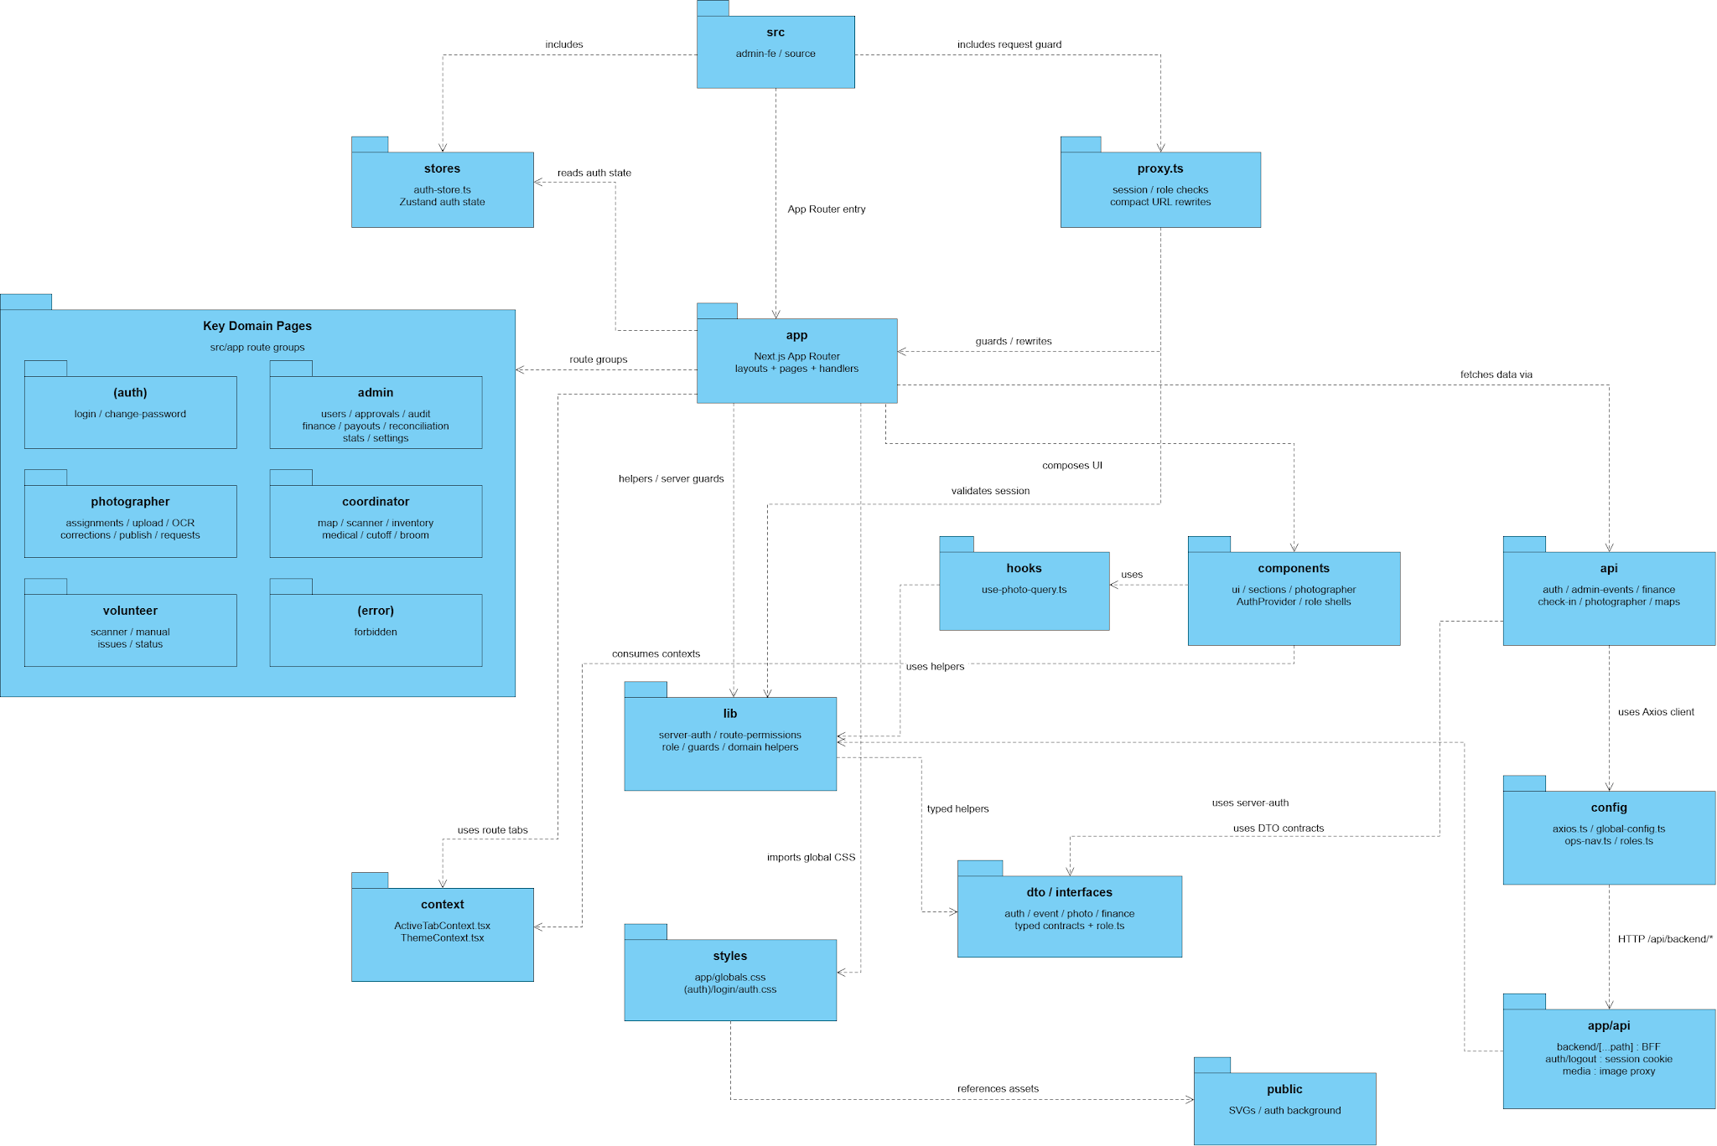
Figure 1.2.3.2 - Admin Web Package Diagram

Package Descriptions
OCR Service Package Diagram Description:
No | Package | Description
01 | main | Application entry point. Creates the FastAPI app, runs YOLO/OCR warmup on startup, exposes health checks and includes the OCR API router.
02 | api | Handles RESTful API routing and incoming HTTP requests for OCR jobs. Defines endpoints to create jobs (JSON / upload), query job status, update event OCR config, and clear dedupe state.
03 | services | Contains the core OCR business logic and pipeline orchestration. Coordinates dedupe, blur quality gate, YOLO person/ROI detection, PaddleOCR recognition, confidence classification, and bib roster matching.
04 | schemas | Defines Pydantic request and response models for OCR jobs, including create-job payloads, options, bib tags, and job results used for validation and serialization.
05 | core | Provides shared cross-cutting configuration and runtime helpers: environment settings, device selection (CPU/CUDA), concurrency limits, and OCR job status constants.
06 | static | Serves demo UI assets, primarily demo.html for manual OCR testing through the browser.
07 | workers | Reserved background worker package for a future Redis consumer that would call the OCR pipeline asynchronously; currently a stub because MVP processes jobs inline in the API.
08 | scripts | Development and smoke-test scripts outside the runtime API, used to verify bib filtering and end-to-end OCR behavior against a running service.

Backend Package Diagram Description:

No | Package | Description
01 | ApiGateway | Public edge gateway (YARP) that routes external HTTP traffic to the RaceDay API Host and applies edge policies such as blocking public access to /admin in Production.
02 | Host | Composition root of the modular monolith (RaceDay.Api). Registers feature modules and maps endpoints only; contains no business rules.
03 | Module.Api | Minimal API endpoints and module DI entry points for each feature module.
04 | Module.Application | Application use-cases implemented with MediatR commands, queries, handlers, and validators for module business workflows.
05 | Module.Domain | Domain model layer containing entities, value objects, and domain rules for each feature module.
06 | Module.Infrastructure | Persistence and external adapters (EF Core/PostgreSQL, outbox, repositories, hosted workers) that implement Application ports.
07 | Module.Contracts | Public cross-module contracts (DTOs and integration events). Other modules may reference Contracts only and not on Domain, Infrastructure, or Api.
08 | Shared.Web | Shared web cross-cutting helpers used by Host and Module.Api, including auth policies and OpenAPI conventions.
09 | Shared.Application | Shared application abstractions and ports (for example current-user access and messaging interfaces) reused by modules.
10 | Shared.Domain | Shared domain primitives and exceptions used across module Domain layers.
11 | Shared.Infrastructure | Shared infrastructure adapters (cache, messaging, EF helpers) registered by the Host and module Infrastructure projects.

Frontend Package Diagram Description (User Web):

No | Package | Description
01 | src | User Web source root. It includes the auth store and the request guard, and it is the App Router entry.
02 | stores | Zustand auth store (auth-token.ts). The app reads the signed-in auth state from here.
03 | proxy.ts | Checks the session and role, then redirects when access control fails.
04 | app | Next.js App Router: layouts, pages and route handlers. It groups routes, guards access, and loads data through the api package.
05 | Key Domain Pages | Route groups for the signed-in and public journeys: account access, events and registration, the user area, photos, results, and the organizer area.
06 | hooks | usePagedList.ts. Validates the session and is used by the UI components.
07 | components | UI for auth, events, organizer, runner, photos and results, plus AuditProvider. This package owns the hooks.
08 | api | Clients for auth, events, organizer, staff, payments, photos, complaints, results and maps. Calls go through the shared Axios client.
09 | lib | Server auth, route permissions, rate limits, guards and domain helpers. Pages use these as helpers and server guards.
10 | components/providers | ToastProvider. Mounts toast notifications for the application.
11 | styles | globals.css and the auth stylesheet. The app imports this global CSS.
12 | dto / interfaces | Typed contracts for auth, event, photo and finance, plus role.ts. Shared by the app, api and components.
13 | config | env.ts and the global configuration. Holds the shared HTTP client used toward the backend.
14 | app/api | BFF routes: backend paths, auth/login and the session cookie. Sends HTTP to the backend.
15 | public | Static images, photos and SVGs. Styles and pages reference these assets.

Frontend Package Diagram Description (Admin Web):

No | Package | Description
01 | src | Admin Web source root (admin-fe). It includes the auth store and the request guard, and it is the App Router entry.
02 | stores | Zustand auth store (auth-store.ts). The app reads the signed-in auth state from here.
03 | proxy.ts | Checks the session and role, and applies the compact URL rewrites.
04 | app | Next.js App Router: layouts, pages and route handlers. It groups routes, guards access, and rewrites or loads data through the api package.
05 | Key Domain Pages | Route groups for each staff role: account access, admin, photographer, coordinator, volunteer, and the forbidden page.
06 | hooks | use-photo-query.ts. Validates the session and is used by the UI components.
07 | components | Shared UI, sections, photographer views, AuditProvider and the role shells. This package owns the hooks.
08 | api | Clients for auth, admin events, finance, check-in, photographer and maps. Calls go through the shared Axios client.
09 | lib | Server auth, route permissions, role checks, guards and domain helpers. Uses server auth and consumes the role context.
10 | context | ActiveRoleContext and ThemeContext. Supplies the active role and theme used by the route tabs.
11 | styles | globals.css and the login auth stylesheet. The app imports this global CSS.
12 | dto / interfaces | Typed contracts for auth, event, photo and finance, plus role.ts. Shared by the app, api and components.
13 | config | env.ts, global configuration, app-nav.ts and role.ts. Holds the shared HTTP client used toward the backend.
14 | app/api | BFF routes: backend paths, auth/login, the session cookie and the image proxy. Sends HTTP to the backend.
15 | public | SVGs and the auth background. Styles and pages reference these assets.

2. Database Design
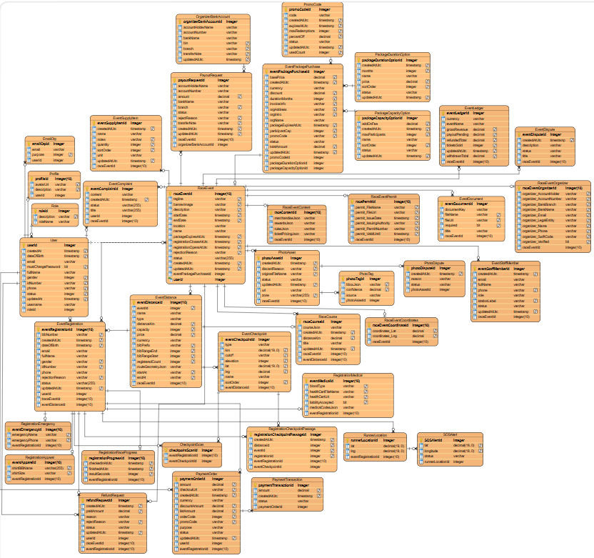

Figure 2 - Database Design
Table Descriptions
No | Table | Description
01 | User | PostgreSQL table iam.users. One sign-in account: username, email, password hash, role, and account status. Email and username are unique.  - Primary keys: userId  - Foreign keys: roleId → Role.roleId (restrict delete)
02 | Role | PostgreSQL table iam.roles. A named role that can be assigned to a user. Role name is unique.  - Primary keys: roleId  - Foreign keys: None
03 | Profile | PostgreSQL table iam.profiles. Contact and verification data for exactly one user. The row uses the same value as User.userId (one-to-one).  - Primary keys: profileId  - Foreign keys: userId → User.userId (cascade delete)
04 | EmailOtp | PostgreSQL table iam.email_otps. A one-time code sent to an email address. userId is stored but is not a foreign key.  - Primary keys: emailOtpId  - Foreign keys: None
05 | RaceEvent | PostgreSQL table event.race_events. One community race: name, date, place, status, map point, organizer, permit, and weather. Those last four groups are columns of this table, not separate tables.  - Primary keys: raceEventId  - Foreign keys: None
06 | EventDistance | PostgreSQL table event.event_distances. One distance of a race (name, kilometres, capacity, and price).  - Primary keys: eventDistanceId  - Foreign keys: eventId → RaceEvent.raceEventId (cascade delete)
07 | EventCheckpoint | PostgreSQL table event.event_checkpoints. One checkpoint that belongs to a distance.  - Primary keys: eventCheckpointId  - Foreign keys: distanceId → EventDistance.eventDistanceId (cascade delete)
08 | EventDocument | PostgreSQL table event.event_documents. A file attached to a race.  - Primary keys: eventDocumentId  - Foreign keys: eventId → RaceEvent.raceEventId (cascade delete)
09 | EventRegistration | PostgreSQL table event.event_registrations. A runner’s entry: identity, bib, status, shirt, medical and emergency fields, quoted fee, and start/finish times. eventId, distanceId, and userId are stored and indexed, but they are not foreign keys. A user can hold only one active entry per event and distance.  - Primary keys: eventRegistrationId  - Foreign keys: None
10 | RegistrationCheckpointPassage | PostgreSQL table event.event_registration_checkpoint_passages. The time a registration passed one checkpoint. registrationId, checkpointId, eventId, and distanceId are stored, not foreign keys. One passage per registration and checkpoint.  - Primary keys: registrationCheckpointPassageId  - Foreign keys: None
11 | EventStaffMember | PostgreSQL table event.event_staff_members. A staff assignment on a race. eventId is stored and indexed, not a foreign key.  - Primary keys: eventStaffMemberId  - Foreign keys: None
12 | EventSupplyItem | PostgreSQL table event.event_supplies. One supply line for a race (name, quantity, unit). eventId is stored and indexed, not a foreign key.  - Primary keys: eventSupplyItemId  - Foreign keys: None
13 | EventComplaint | PostgreSQL table event.event_complaints. A complaint filed about a race.  - Primary keys: eventComplaintId  - Foreign keys: None
14 | EventDispute | PostgreSQL table event.event_disputes. A dispute opened against a race.  - Primary keys: eventDisputeId  - Foreign keys: eventId → RaceEvent.raceEventId (restrict delete)
15 | PromoCode | PostgreSQL table event.promo_codes. A discount code that can be applied to a purchase.  - Primary keys: promoCodeId  - Foreign keys: None
16 | PackageDurationOption | PostgreSQL table event.package_duration_options. A sellable organizer-package length, with a price. Months is unique.  - Primary keys: packageDurationOptionId  - Foreign keys: None
17 | PackageCapacityOption | PostgreSQL table event.package_capacity_options. A sellable participant-capacity add-on, with a fee. MaxParticipants is unique.  - Primary keys: packageCapacityOptionId  - Foreign keys: None
18 | EventPackagePurchase | PostgreSQL table event.package_purchases. An organizer’s purchase of a duration and capacity package.  - Primary keys: eventPackagePurchaseId  - Foreign keys: None
19 | PaymentOrder | PostgreSQL table payment.payments. A checkout order. registrationId, referenceId, and userId are stored identifiers, not foreign keys.  - Primary keys: paymentOrderId  - Foreign keys: None
20 | PaymentTransaction | PostgreSQL table payment.payment_transactions. One attempt or result recorded against a payment order.  - Primary keys: paymentTransactionId  - Foreign keys: paymentOrderId → PaymentOrder.paymentOrderId
21 | OrganizerBankAccount | PostgreSQL table finance.organizer_bank_accounts. The bank account an organizer uses for payout. organizerUserId is stored, not a foreign key.  - Primary keys: organizerBankAccountId  - Foreign keys: None
22 | PayoutRequest | PostgreSQL table finance.payout_requests. An organizer’s request to withdraw money from an event. eventId and organizerUserId are stored, not foreign keys.  - Primary keys: payoutRequestId  - Foreign keys: None
23 | RefundRequest | PostgreSQL table finance.refund_requests. A request to refund a payment. paymentId, registrationId, eventId, and userId are stored, not foreign keys.  - Primary keys: refundRequestId  - Foreign keys: None
24 | EventLedger | PostgreSQL table finance.event_ledgers. The money position of one event. eventId and organizerUserId are stored, not foreign keys.  - Primary keys: eventLedgerId  - Foreign keys: None
25 | PlatformFinanceSettings | PostgreSQL table finance.platform_settings. Platform fee settings. Add this row only if the figure has a box for it.  - Primary keys: platformFinanceSettingsId  - Foreign keys: None
26 | PhotoAsset | PostgreSQL table photo.photos. A race photo and its publish status. eventId and uploadedByUserId are stored, not foreign keys.  - Primary keys: photoAssetId  - Foreign keys: None
27 | PhotoTag | PostgreSQL table photo.photo_tags. A bib detected on a photo, with confidence and bounding box.  - Primary keys: photoTagId  - Foreign keys: photoAssetId → PhotoAsset.photoAssetId (cascade delete)
28 | PhotoDispute | PostgreSQL table photo.photo_disputes. A report against a photo. photoId, eventId, and reporterUserId are stored, not foreign keys.  - Primary keys: photoDisputeId  - Foreign keys: None
29 | RaceCourse | PostgreSQL table map.race_courses. The course geometry published for a race.  - Primary keys: raceCourseId  - Foreign keys: None
30 | RunnerLocation | PostgreSQL table race_monitoring.runner_locations. A GPS point recorded for a registration. registrationId is stored, not a foreign key.  - Primary keys: runnerLocationId  - Foreign keys: None
31 | CheckpointScan | PostgreSQL table race_monitoring.checkpoint_scans. A checkpoint scan for a registration. registrationId and checkpointId are stored, not foreign keys.  - Primary keys: checkpointScanId  - Foreign keys: None
32 | SOSAlert | PostgreSQL table race_monitoring.sos_alerts. An SOS raised for a registration, optionally tied to a runner location. registrationId is stored, not a foreign key.  - Primary keys: sosAlertId  - Foreign keys: runnerLocationId → RunnerLocation.runnerLocationId (optional, restrict delete)
33 | DeviceAuthRequest | PostgreSQL table device.device_auth_requests. A device sign-in code. Add this row only if the figure draws the box.  - Primary keys: deviceAuthRequestId  - Foreign keys: None
34 | LinkedDevice | PostgreSQL table device.linked_devices. A device linked to an account. Add this row only if the figure draws the box.  - Primary keys: linkedDeviceId  - Foreign keys: None
35 | SosAlert | PostgreSQL table device.sos_alerts. An SOS sent by a linked wearable. This is separate from race_monitoring.sos_alerts. Add the row only if the figure draws this box.  - Primary keys: sosAlertId  - Foreign keys: None
36 | SosLocation | PostgreSQL table device.sos_locations. A location sample attached to a wearable SOS.  - Primary keys: sosLocationId  - Foreign keys: sosAlertId → SosAlert.sosAlertId (device)

3. Detailed Design

3.1 Authentication & Authorization

3.1.1 Class Diagram

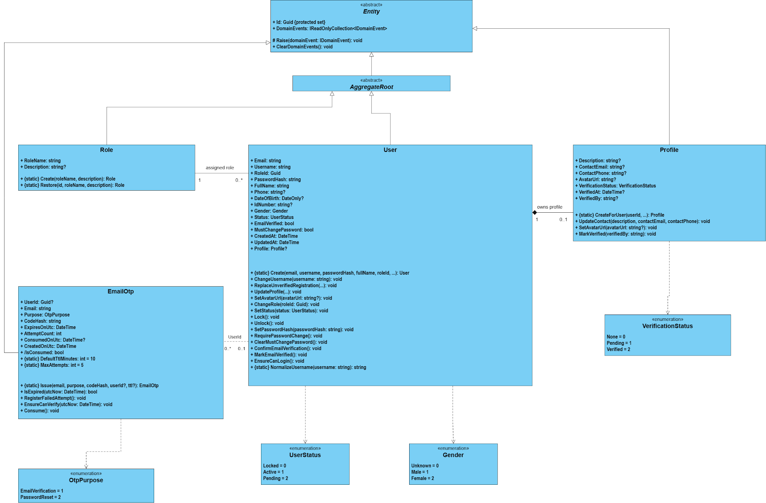
Figure 3.1.1

3.1.2 Sequence Diagram: Login

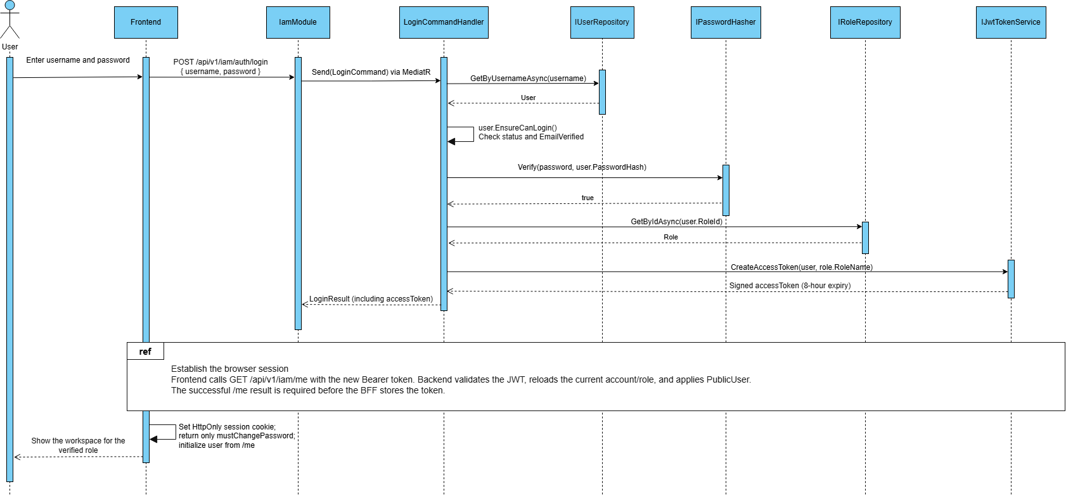
Figure 3.1.2

3.1.3 Sequence Diagram: Register

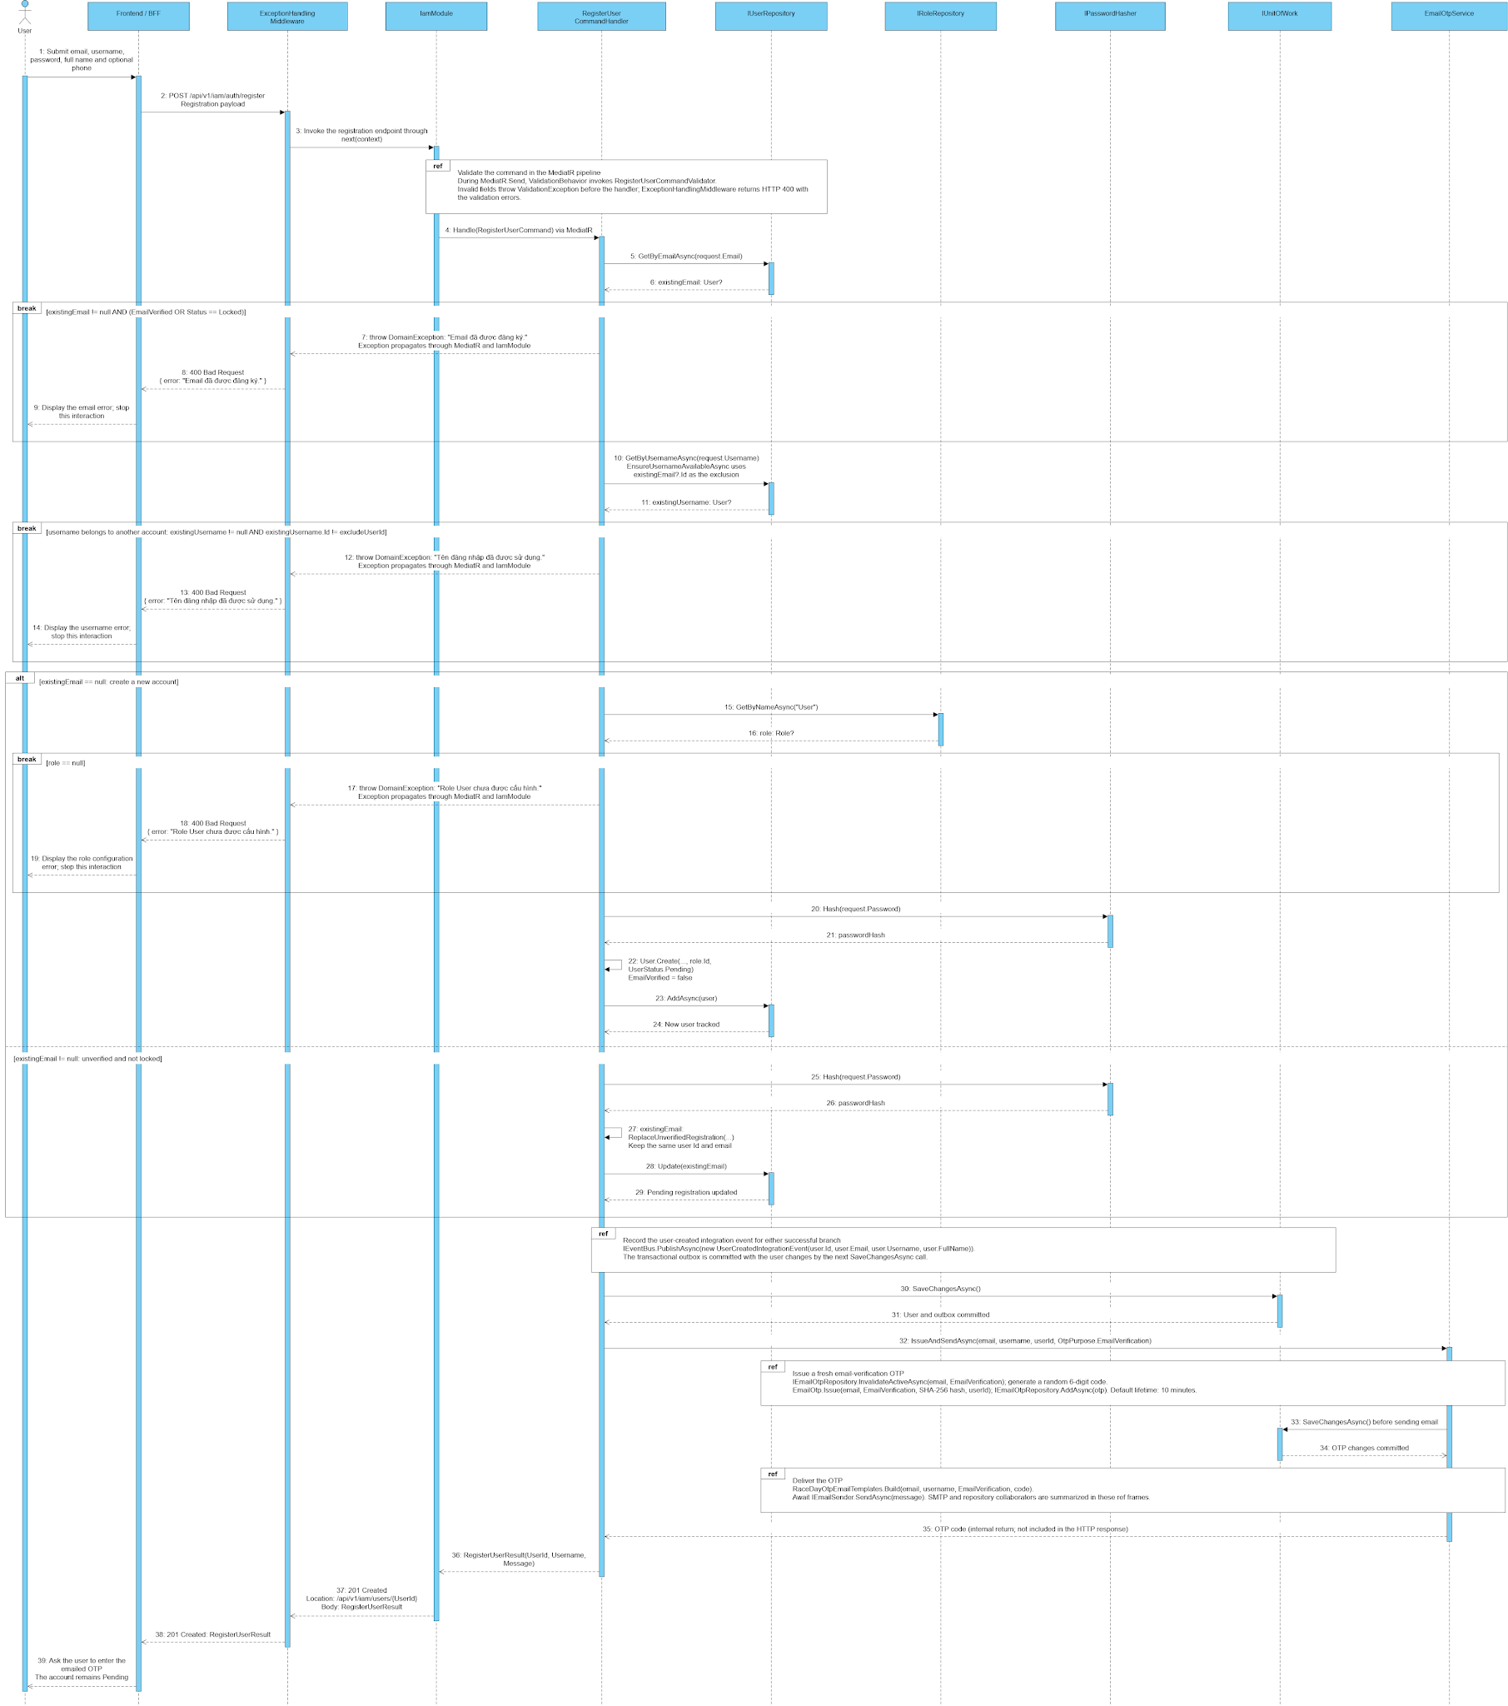
Figure 3.1.3

3.1.4 Sequence Diagram: Role Authorization

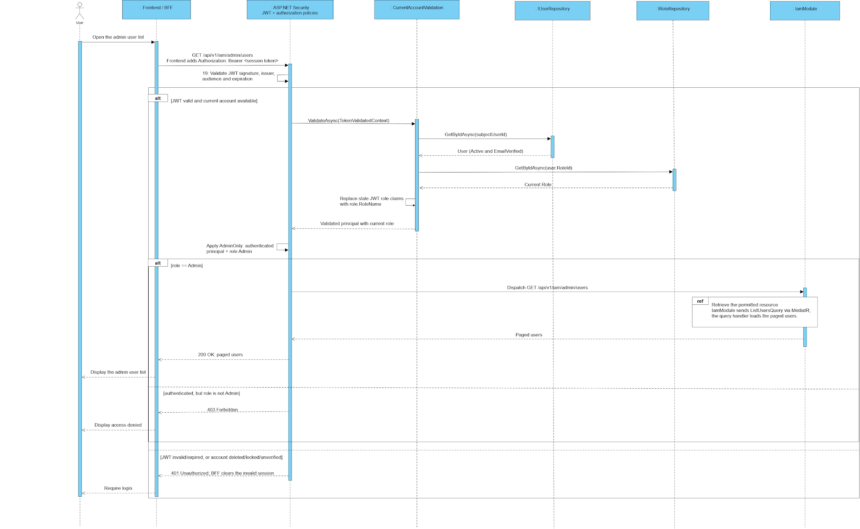
Figure 3.1.4

3.2 Event Management

3.2.1 Class Diagram
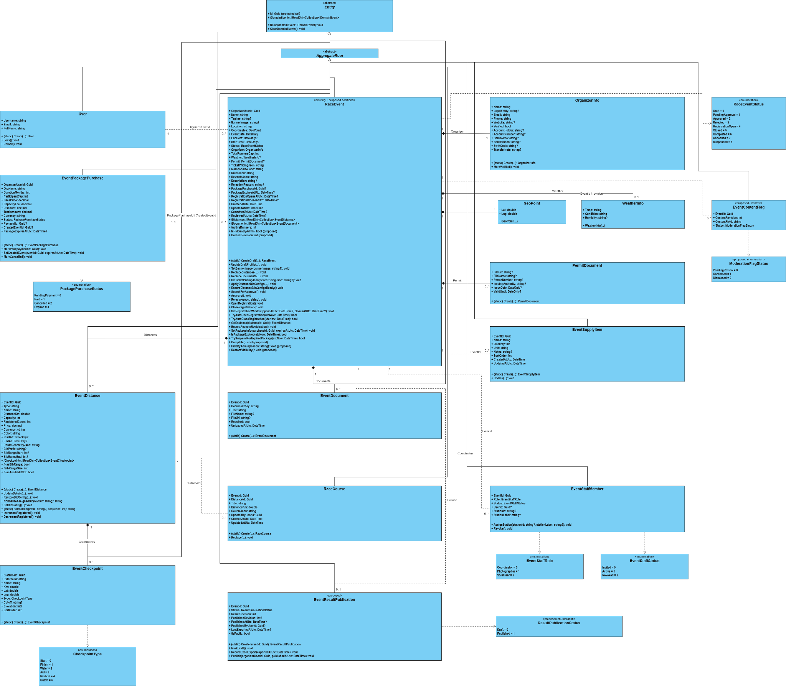
Figure 3.2.1

3.2.2 Sequence diagram:Create Event
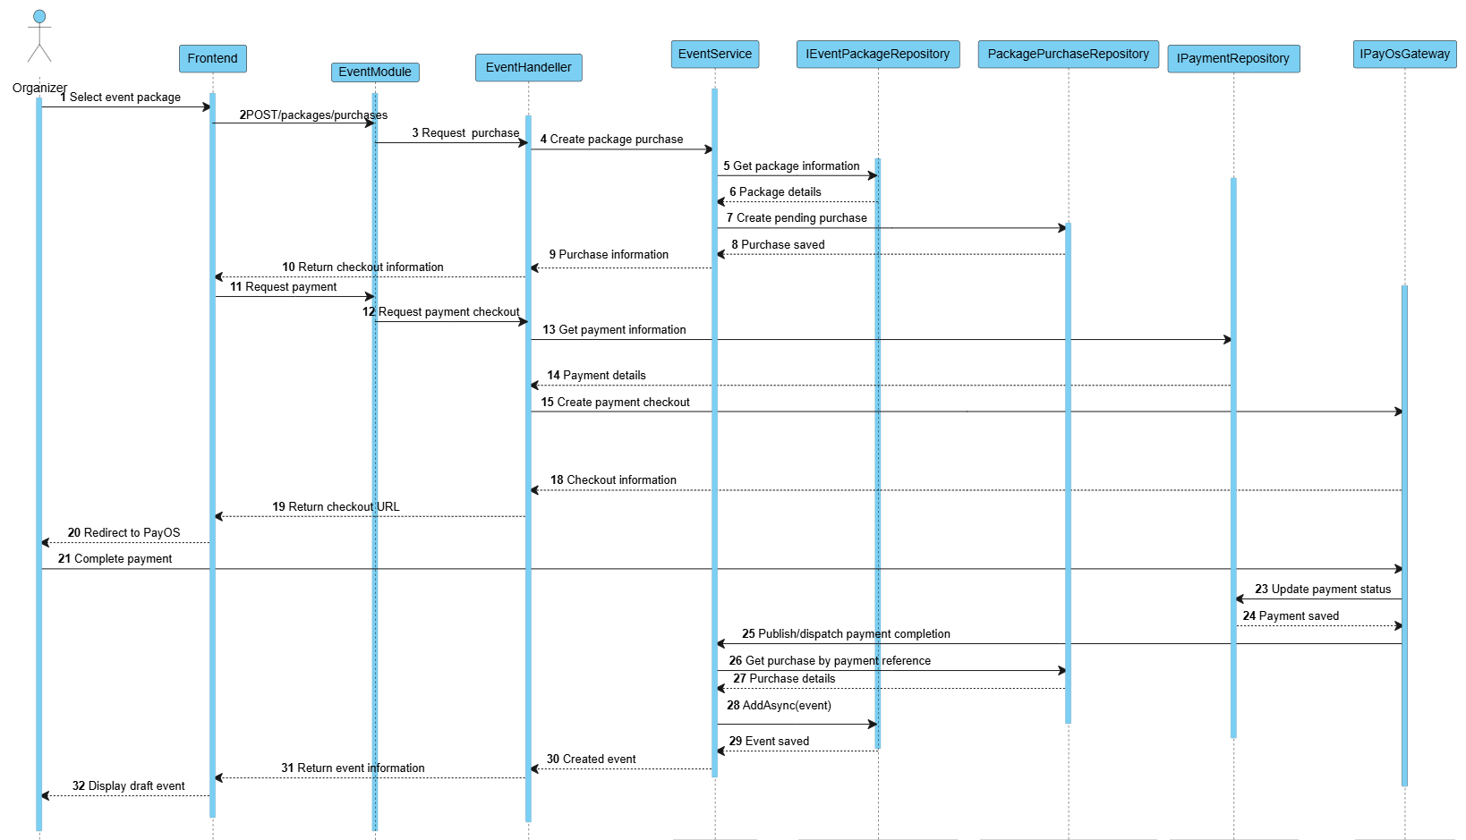
Figure 3.2.2

3.2.3 Sequence diagram:Update Event
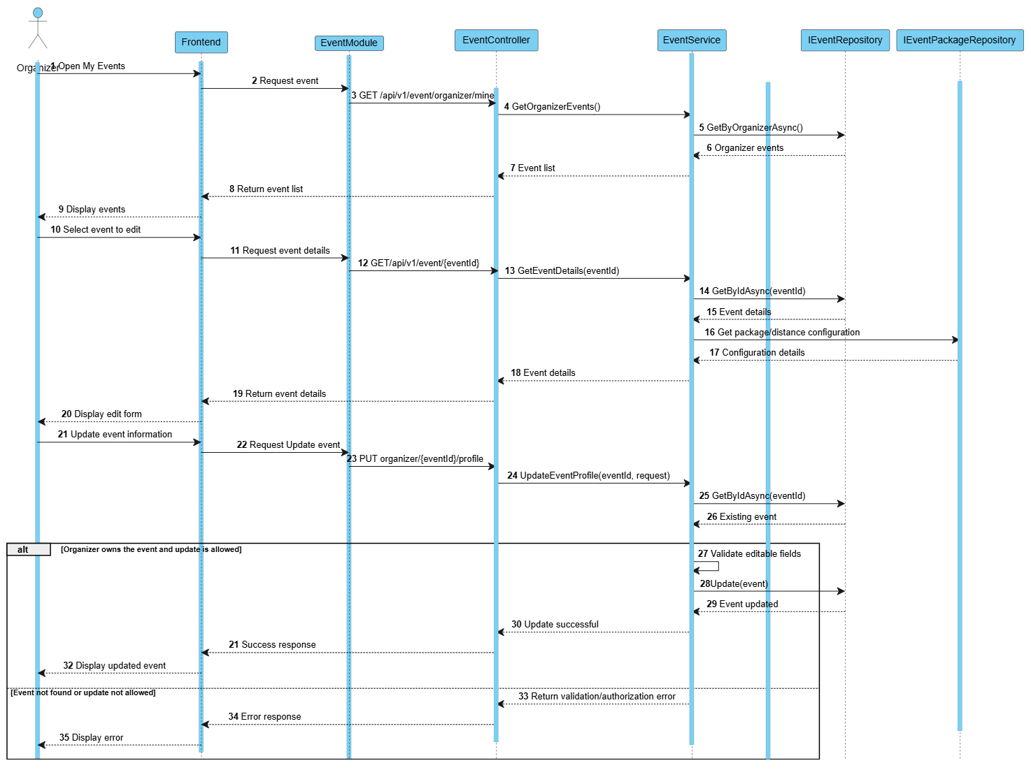
Figure 3.2.3

3.2.4 Sequence diagram:Publish Event
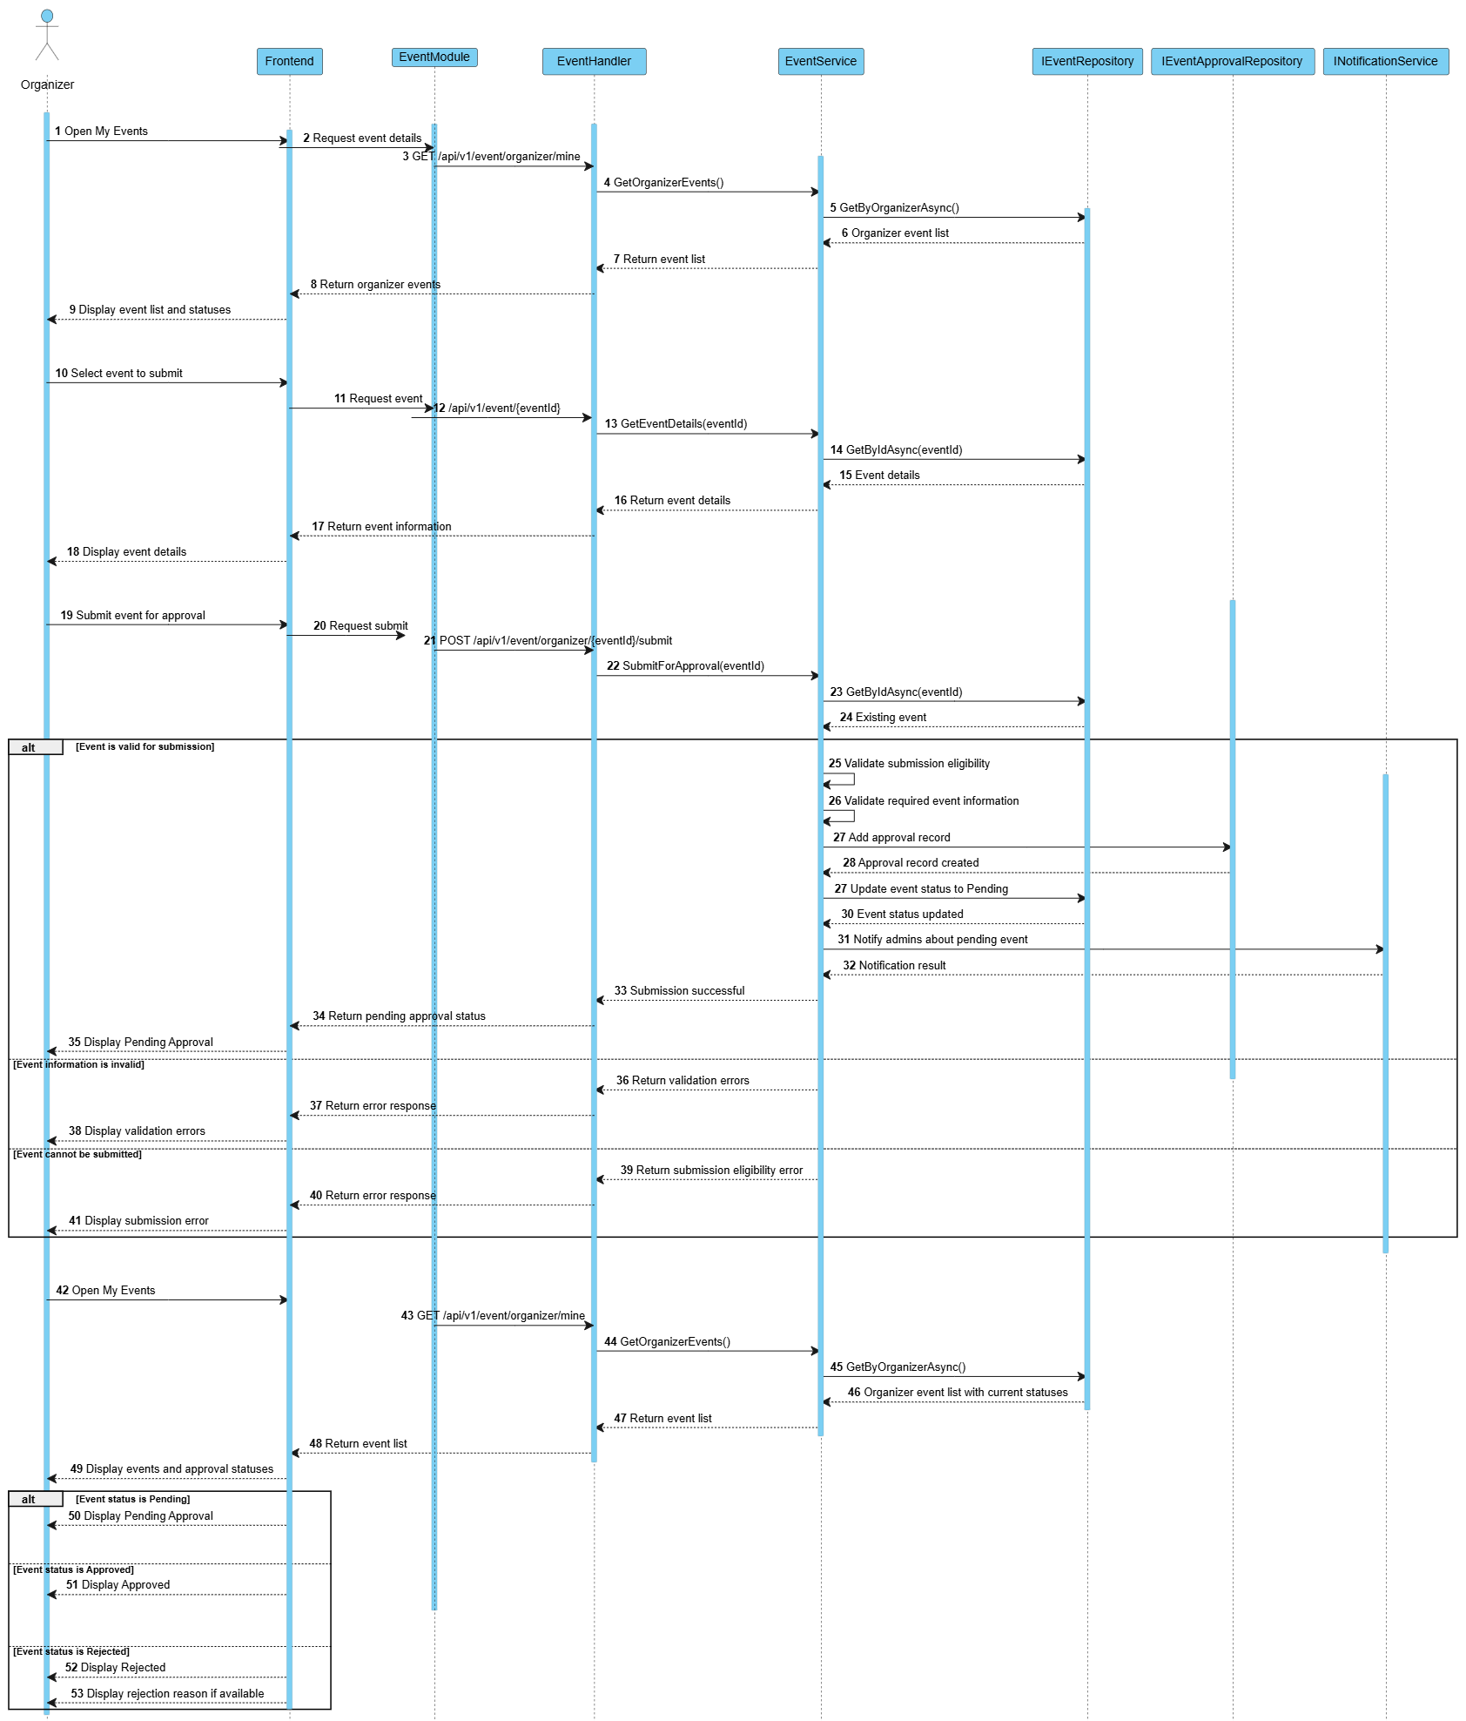
Figure3.2.4

3.3 Runner Registration & Payment

3.3.1 Class Diagram
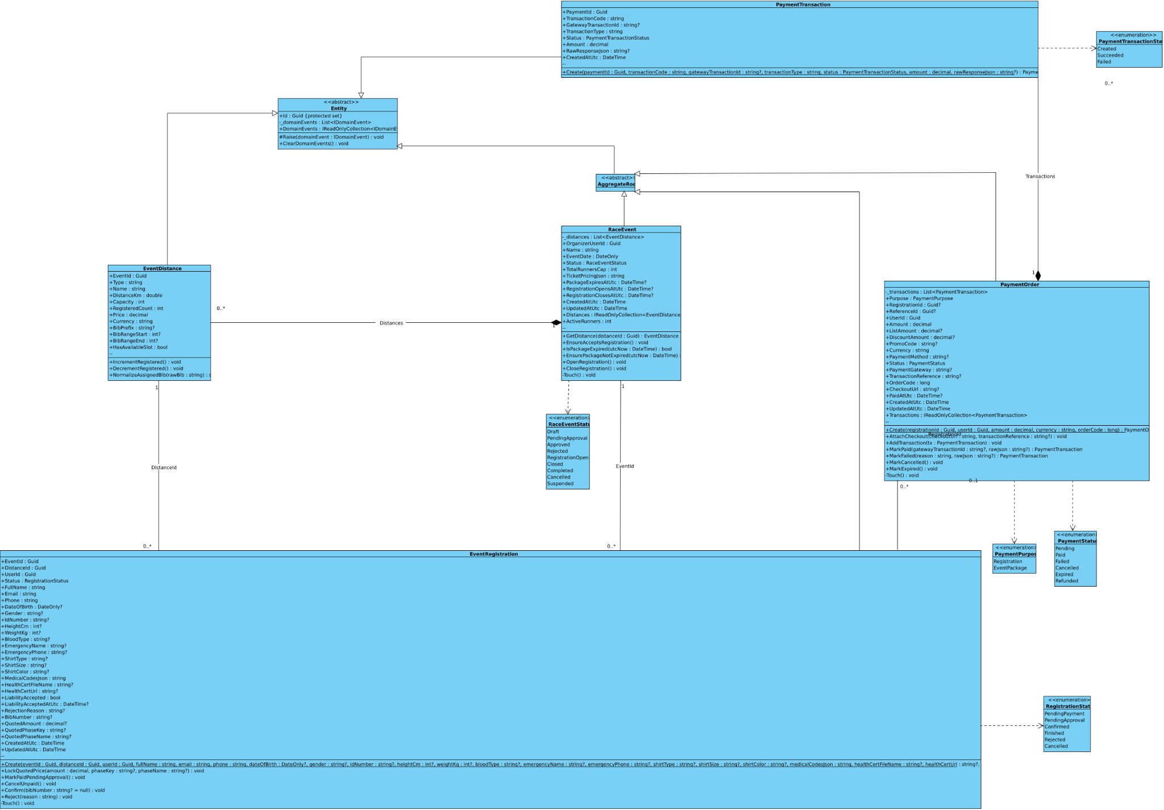
Figure 3.3.1

3.3.2 Sequence diagram:Register For Event
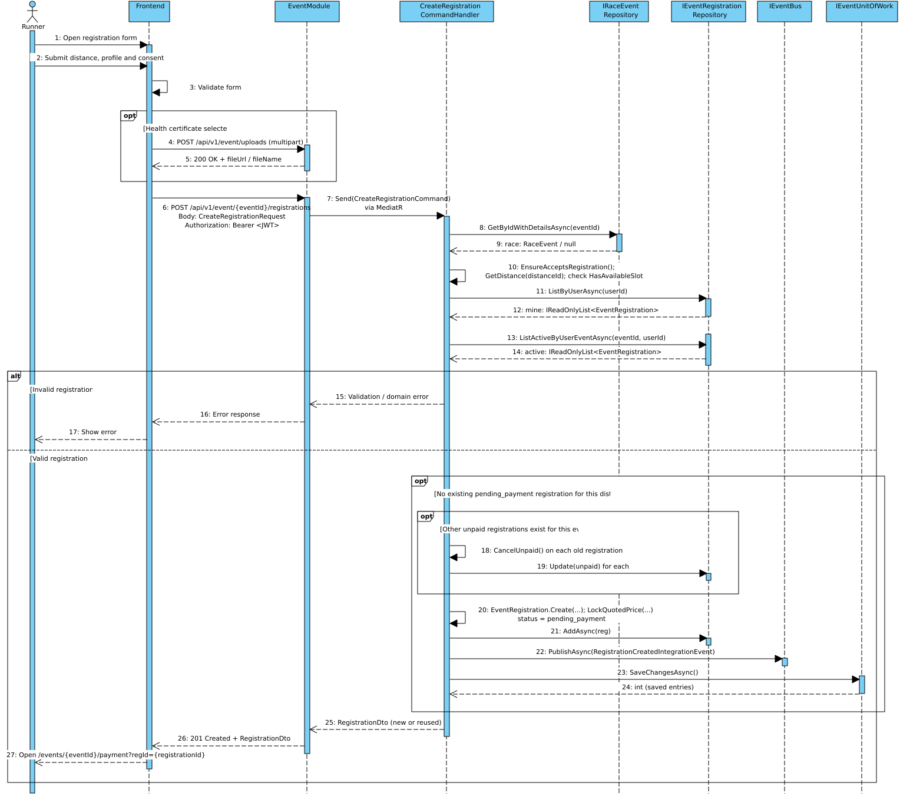
Figure 3.3.2

3.3.3 Sequence diagram:Process PayOS Payment
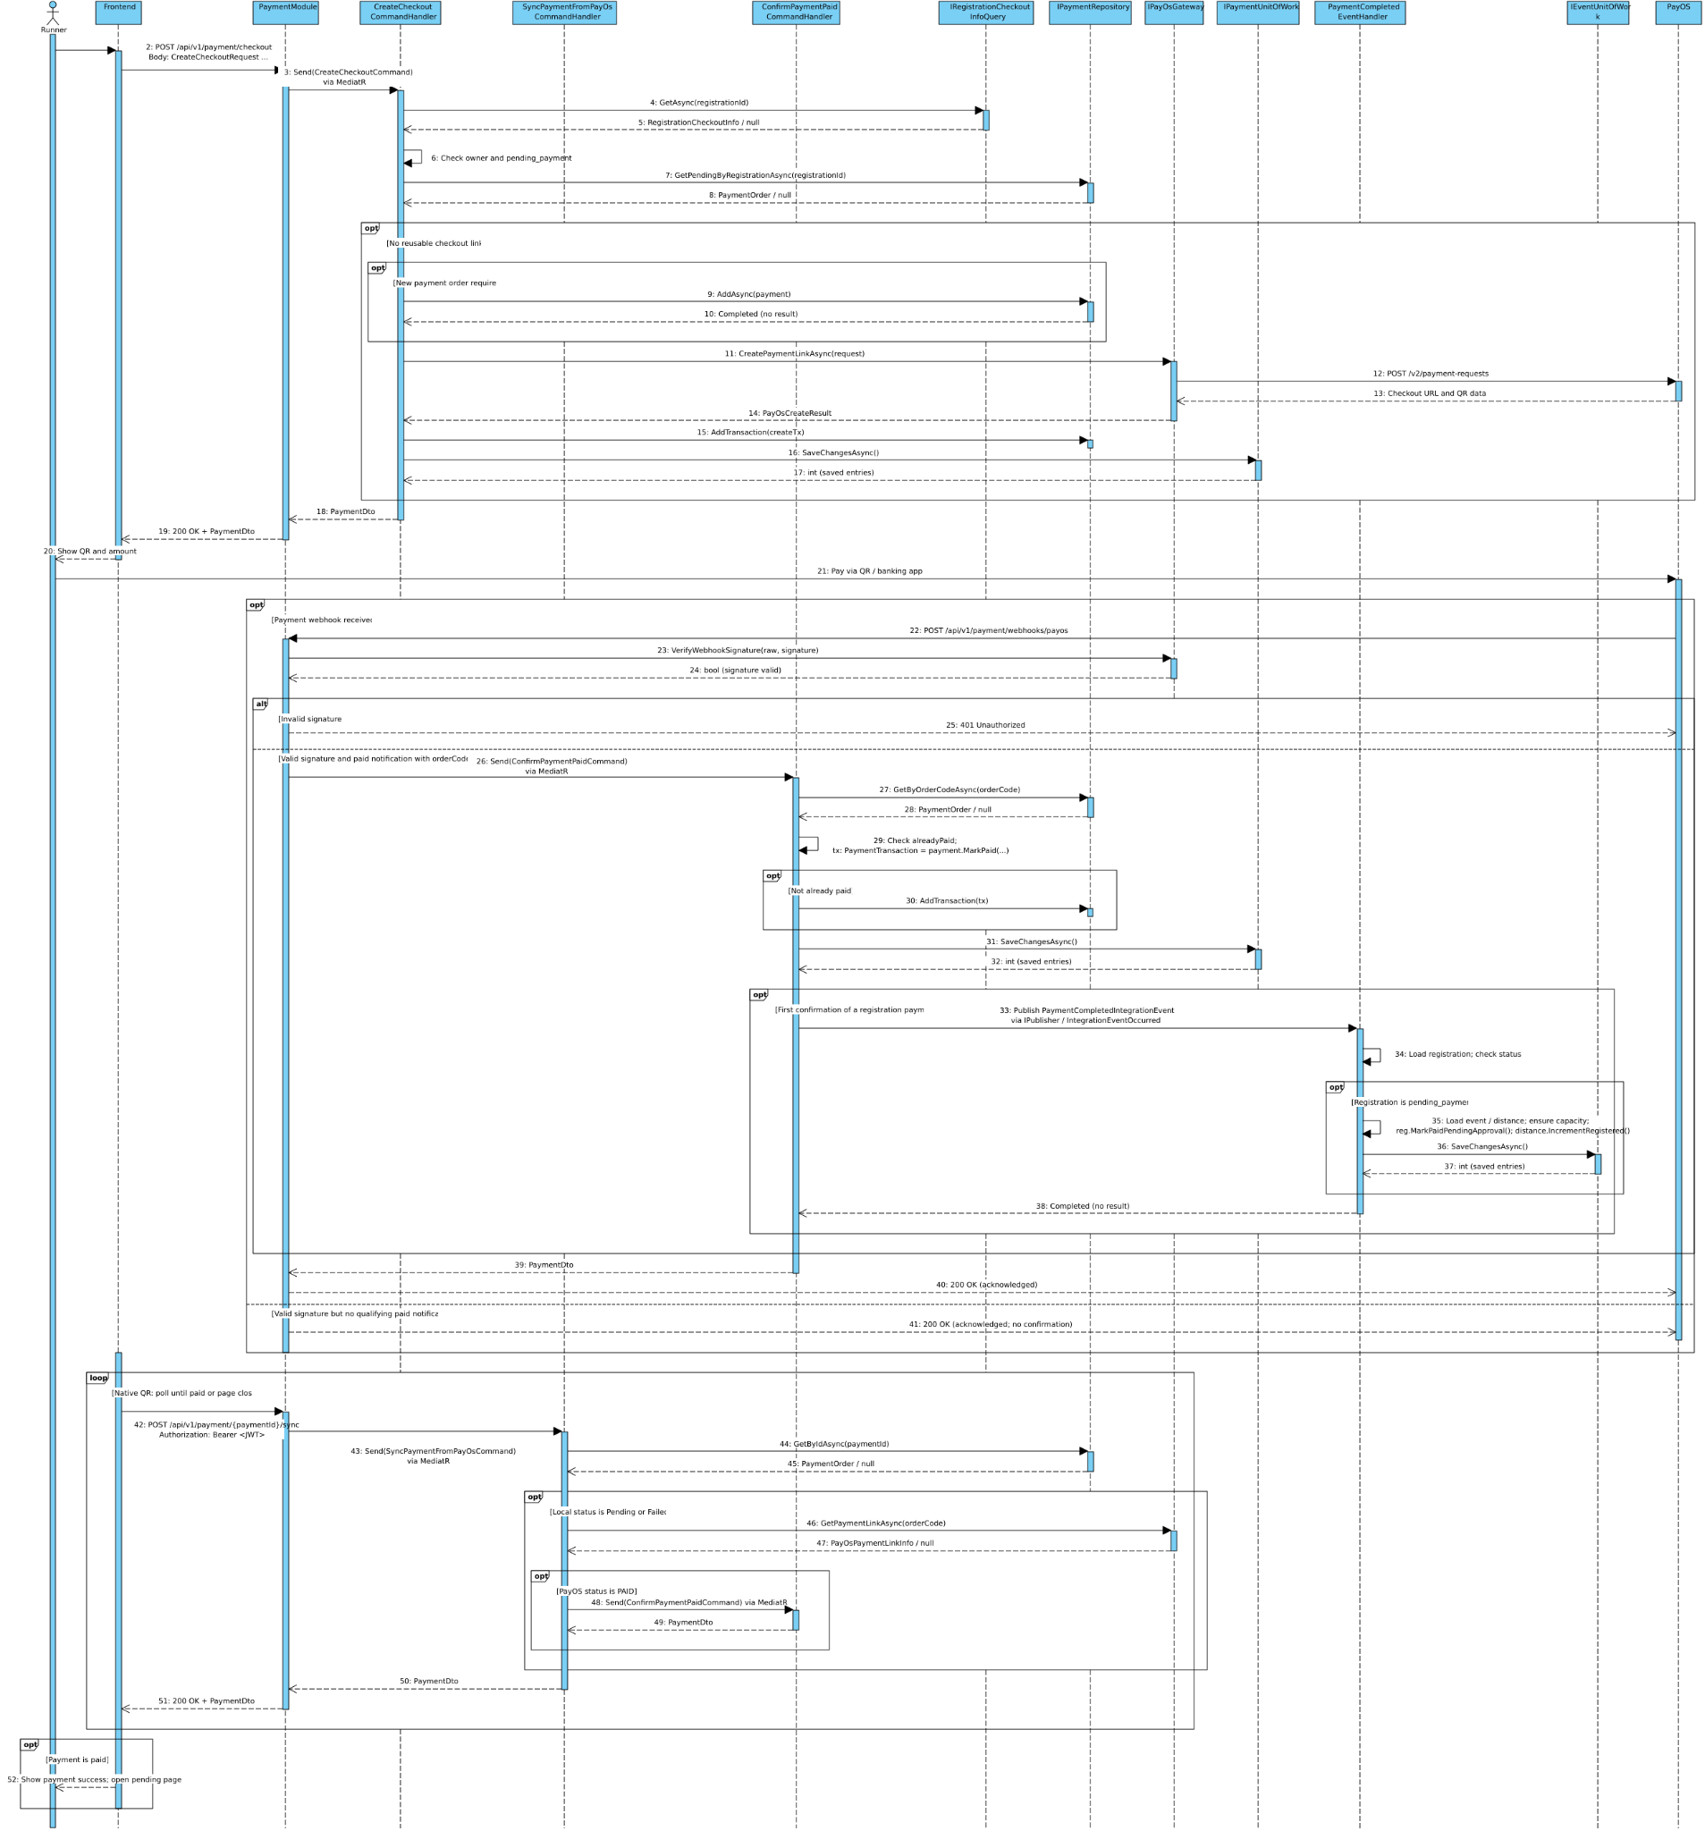
Figure 3.3.3

3.4 QR Code Check-in

3.4.1 Class Diagram
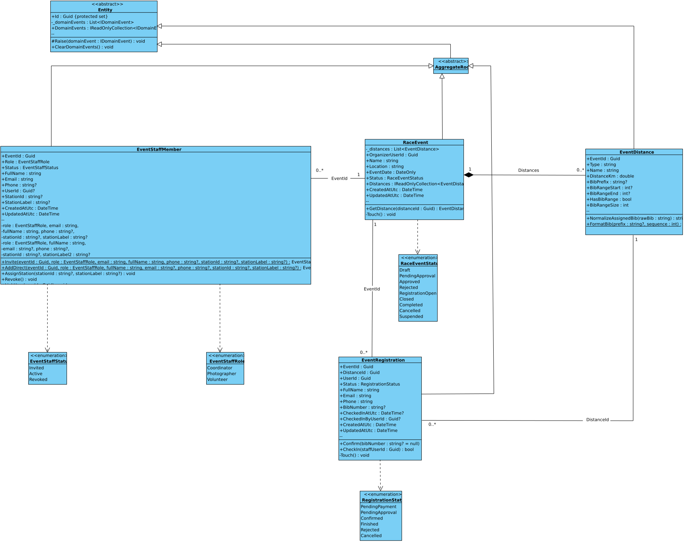
Figure 3.4.1

3.4.2 Sequence diagram:QR code & Check-in
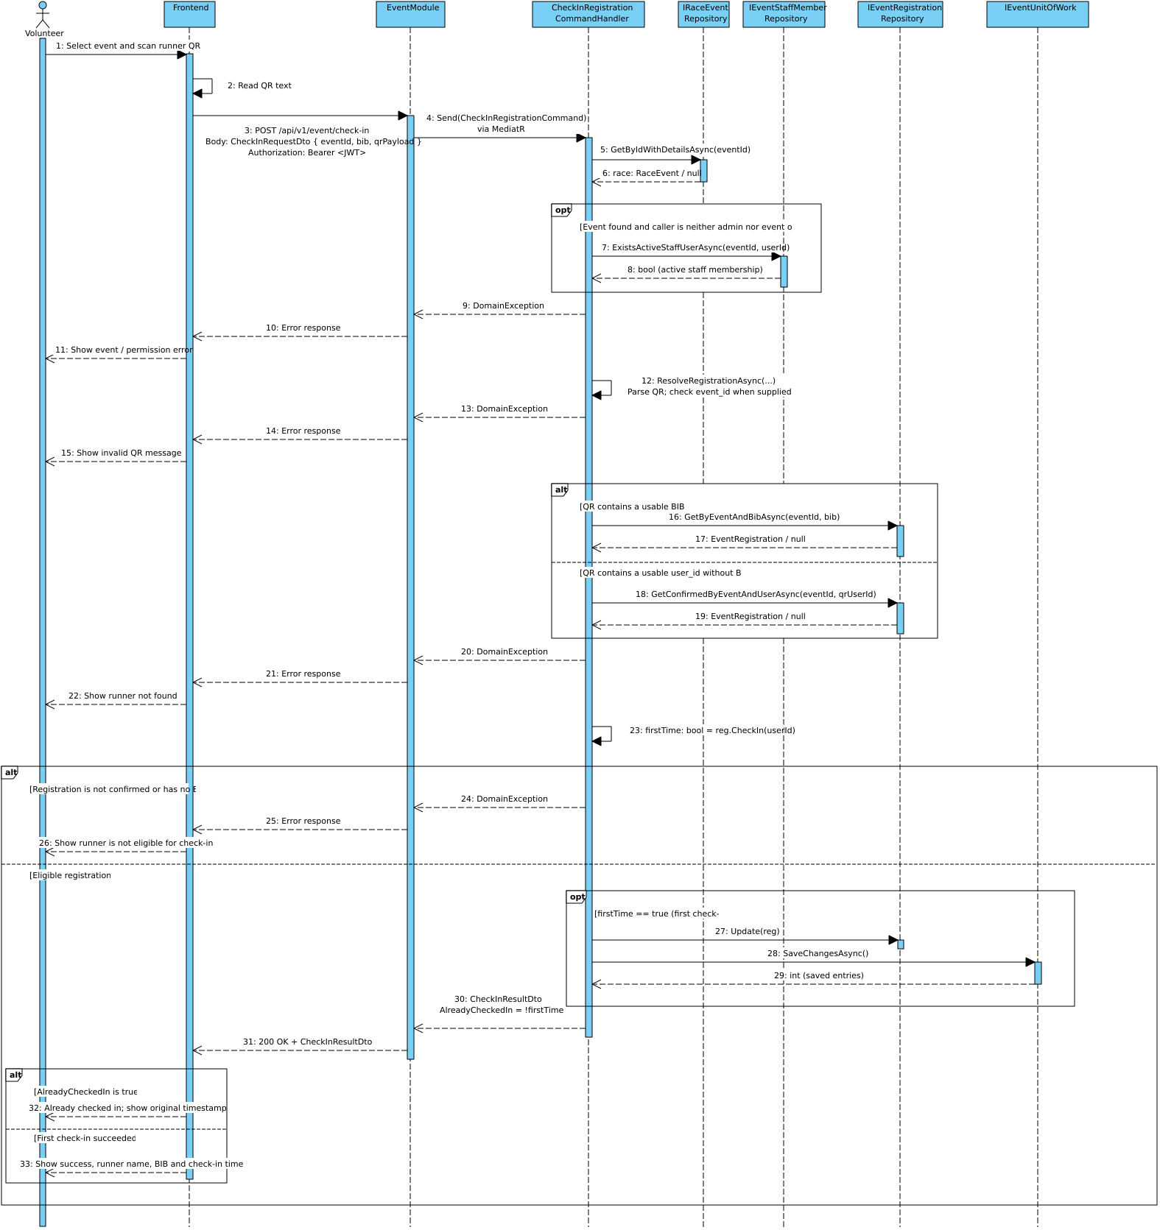
Figure 3.4.2

3.5 RFID Checkpoint tracking

3.5.1 Class Diagram
Figure 3.2.1

3.5.2 Sequence diagram:Create Event
Figure 3.2.2

3.5.3 Sequence diagram:Update Event

Figure 3.2.3

3.5.4 Sequence diagram:Publish Event
Figure 3.2.4

3.6 Race Results Management

3.6.1 Class Diagram
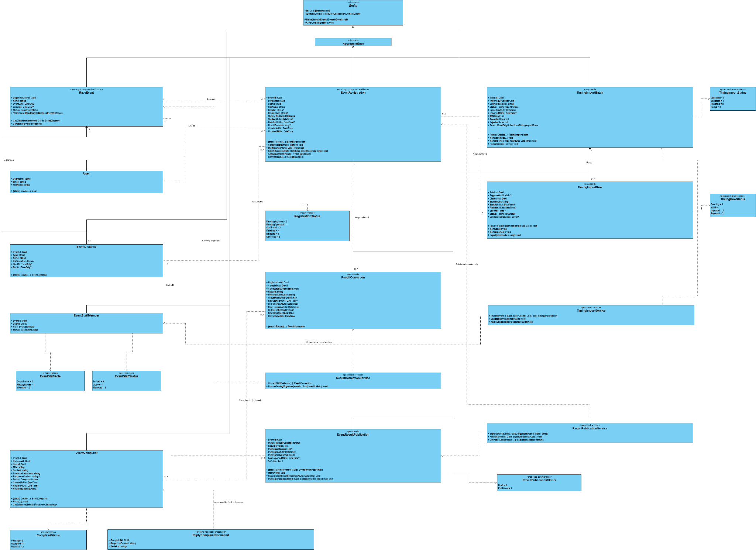
Figure3.6.1

3.6.2 Sequence diagram:Record Finish Time
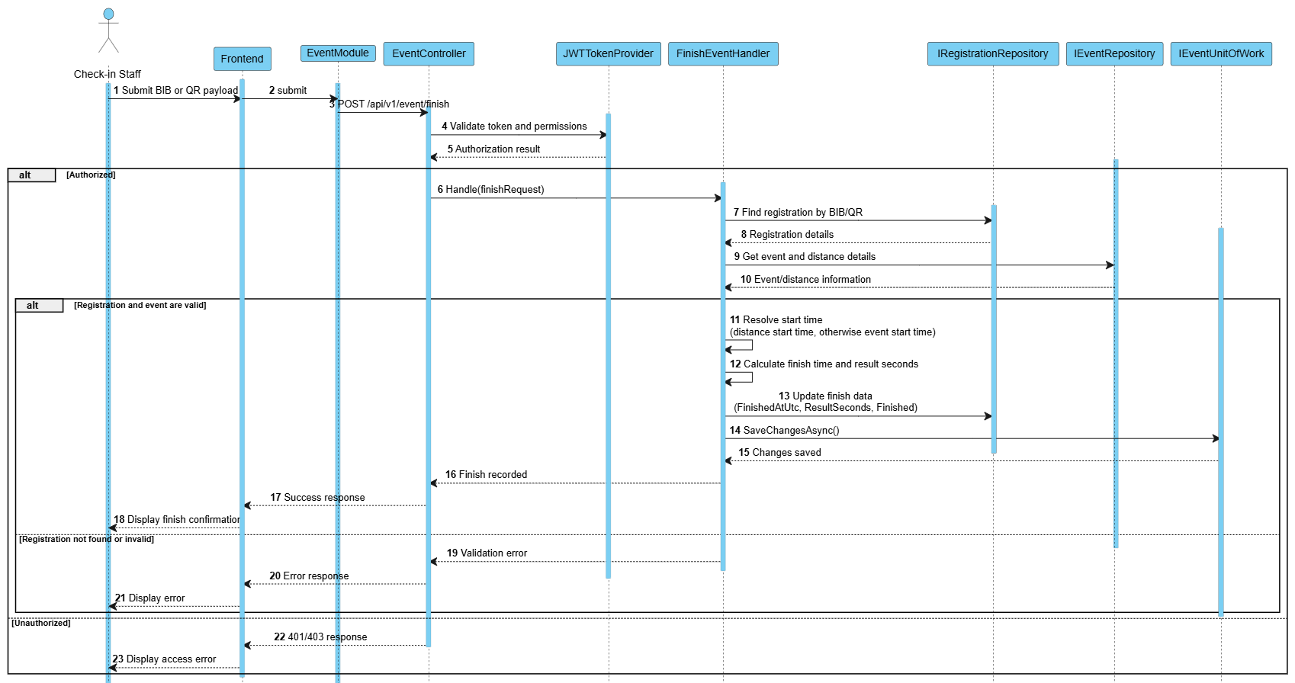
Figure3.6.2
3.6.3 Sequence diagram:Generate Leaderboard
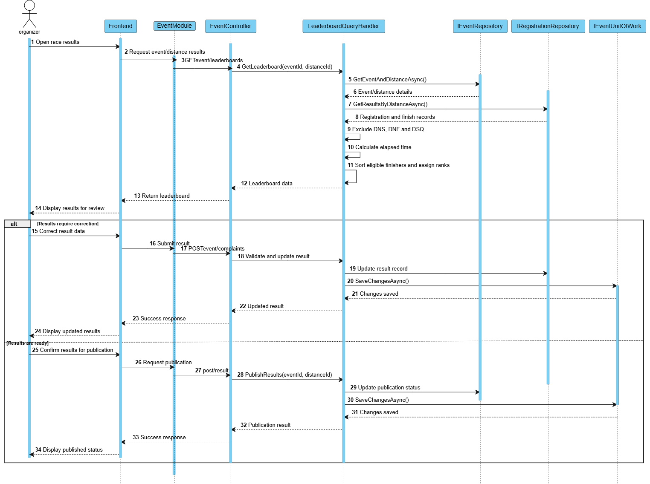 Figure 3.6.3

3.6.4 Sequence diagram:Generate Certificate

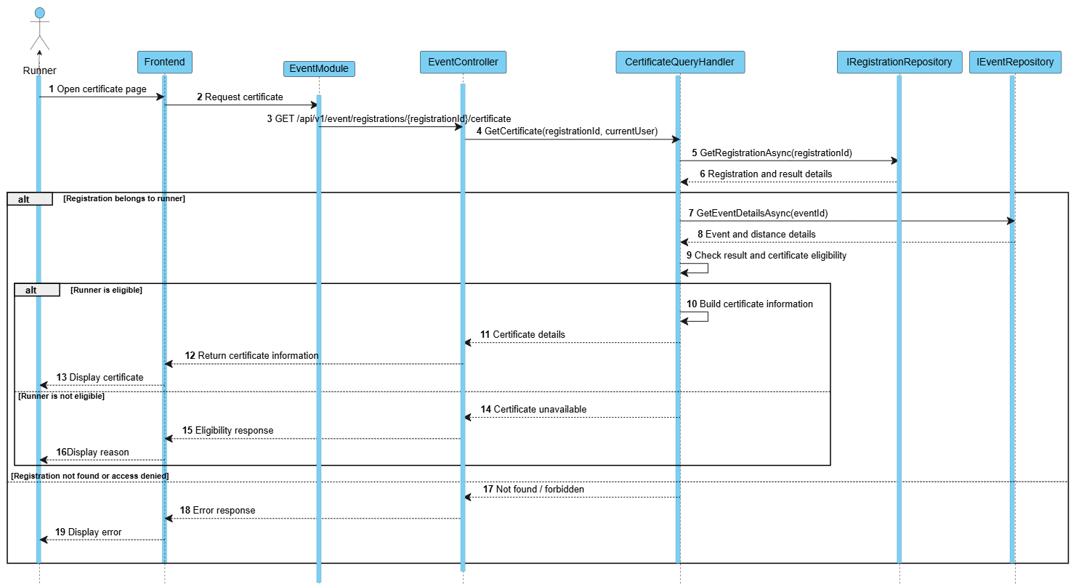
Figure 3.6.4

3.7 Photo Management

3.7.1 Class Diagram

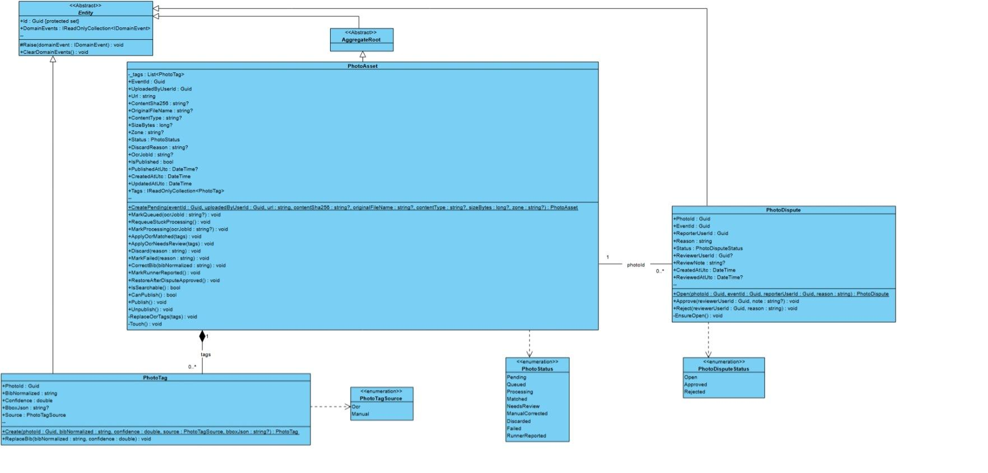
Figure 3.7.1

3.7.2 Sequence diagram: Bulk Upload Images
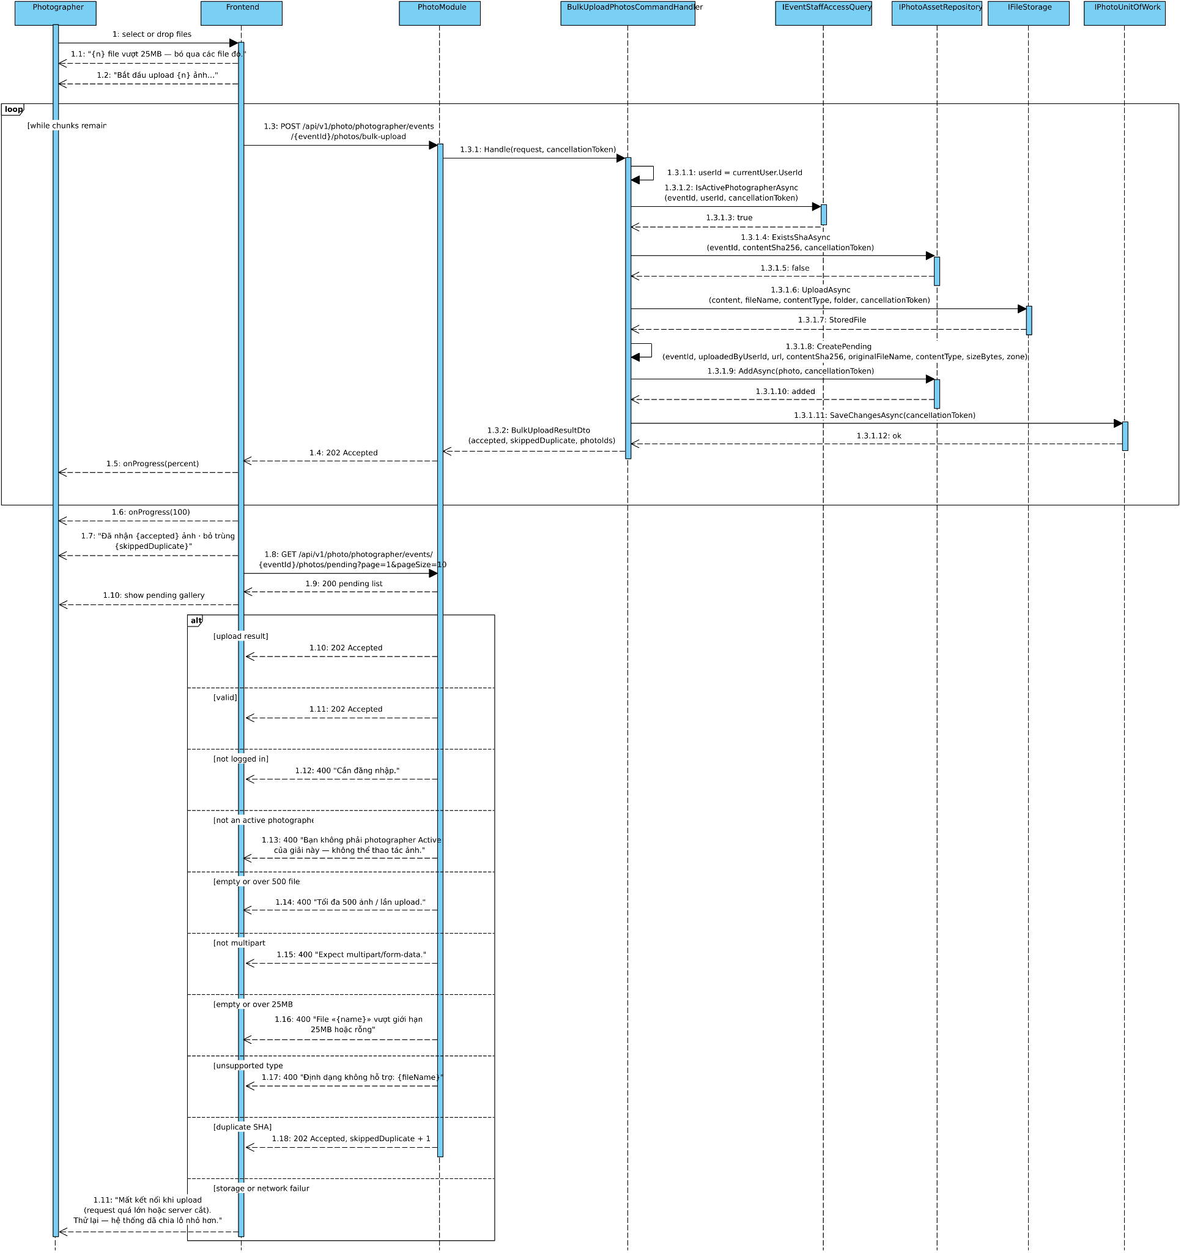
Figure 3.7.2

3.7.3 Sequence diagram: Photo OCR Recognition
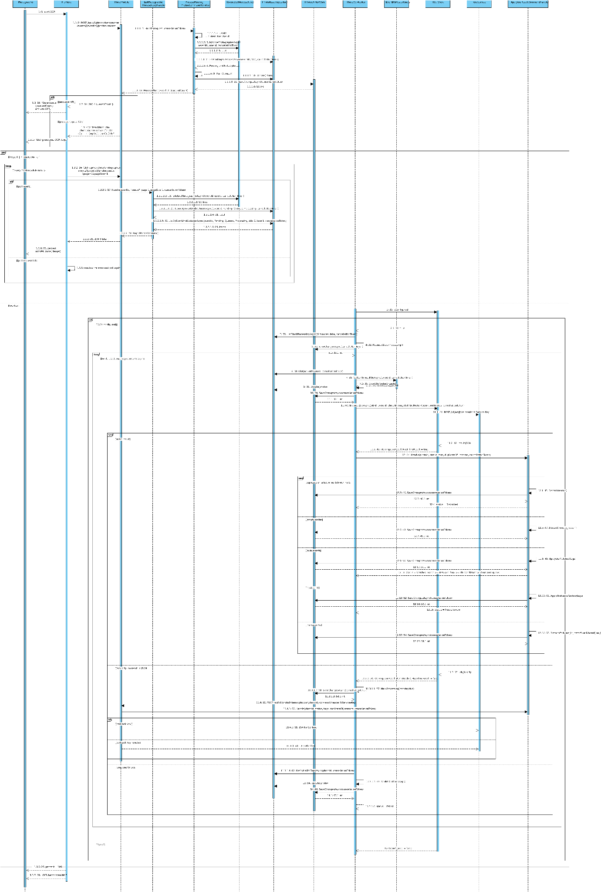

Figure 3.7.3

3.7.4 Sequence diagram: Review BIB and Publish
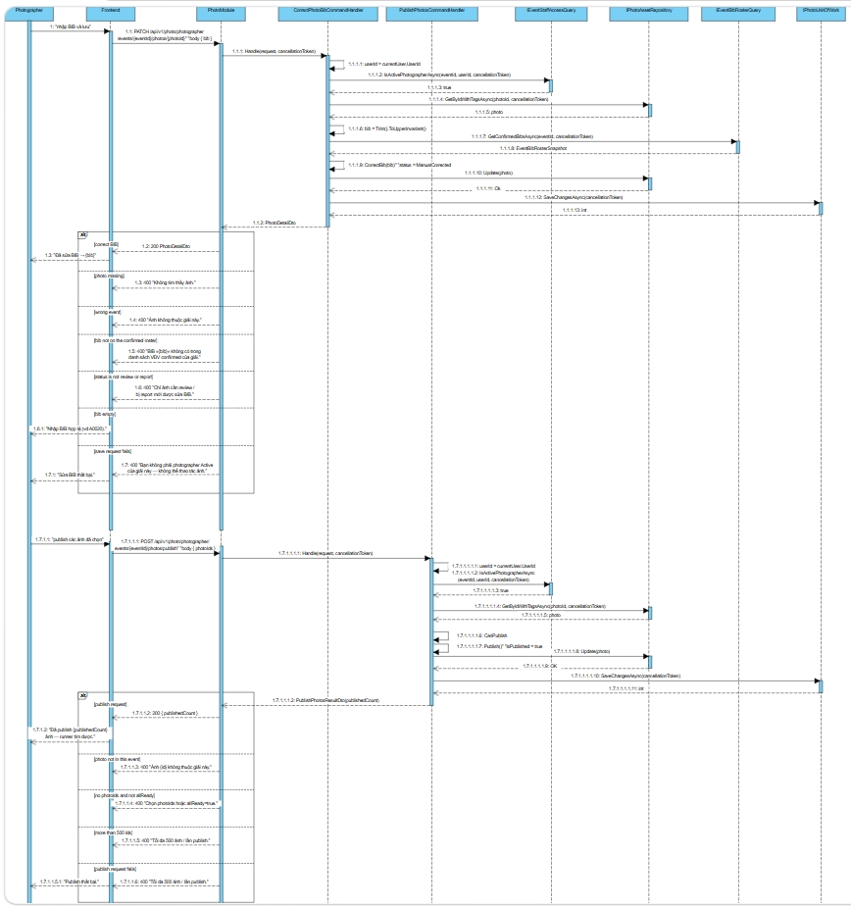

Figure 3.7.4

3.7.5 Sequence diagram: Search BIB and dispute
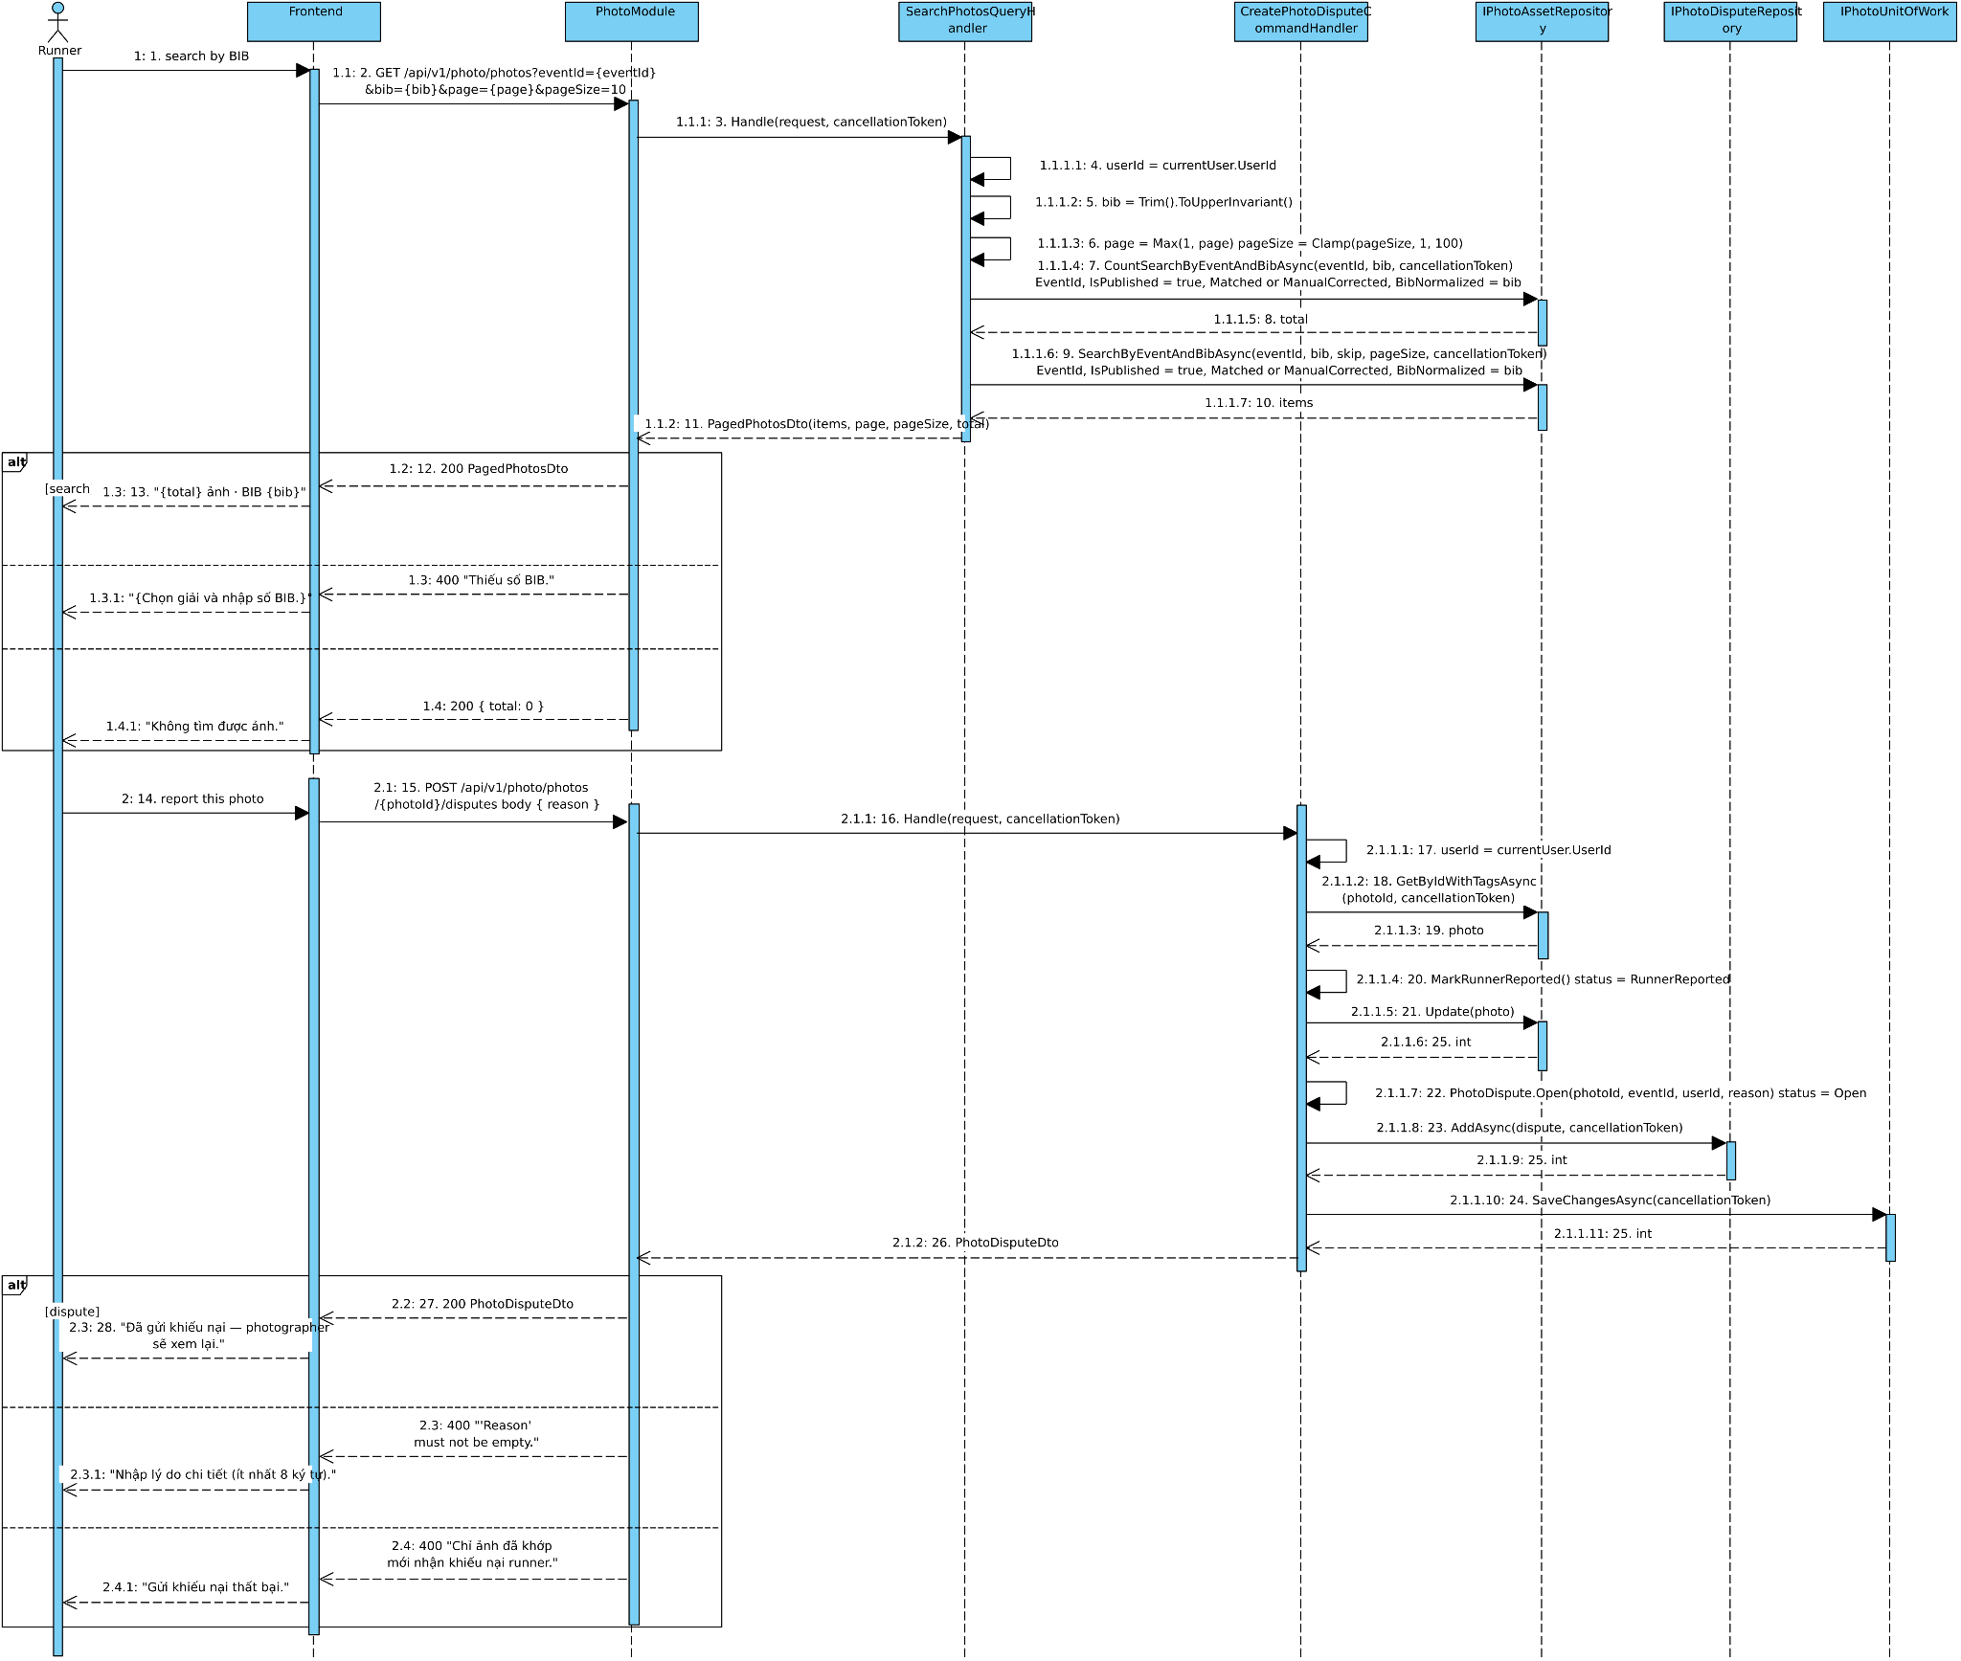
Figure 3.7.5

3.8 Race Coordination

3.8.1 Class Diagram
Figure 3.2.1

3.8.2 Sequence diagram: Submit SOS
Figure 3.2.2

3.8.3 Sequence diagram: Handle SOS
Figure 3.2.3

3.8.4 Sequence diagram: Cut-off time
Figure 3.2.4

3.9 Event Staff Management

3.9.1 Class Diagram
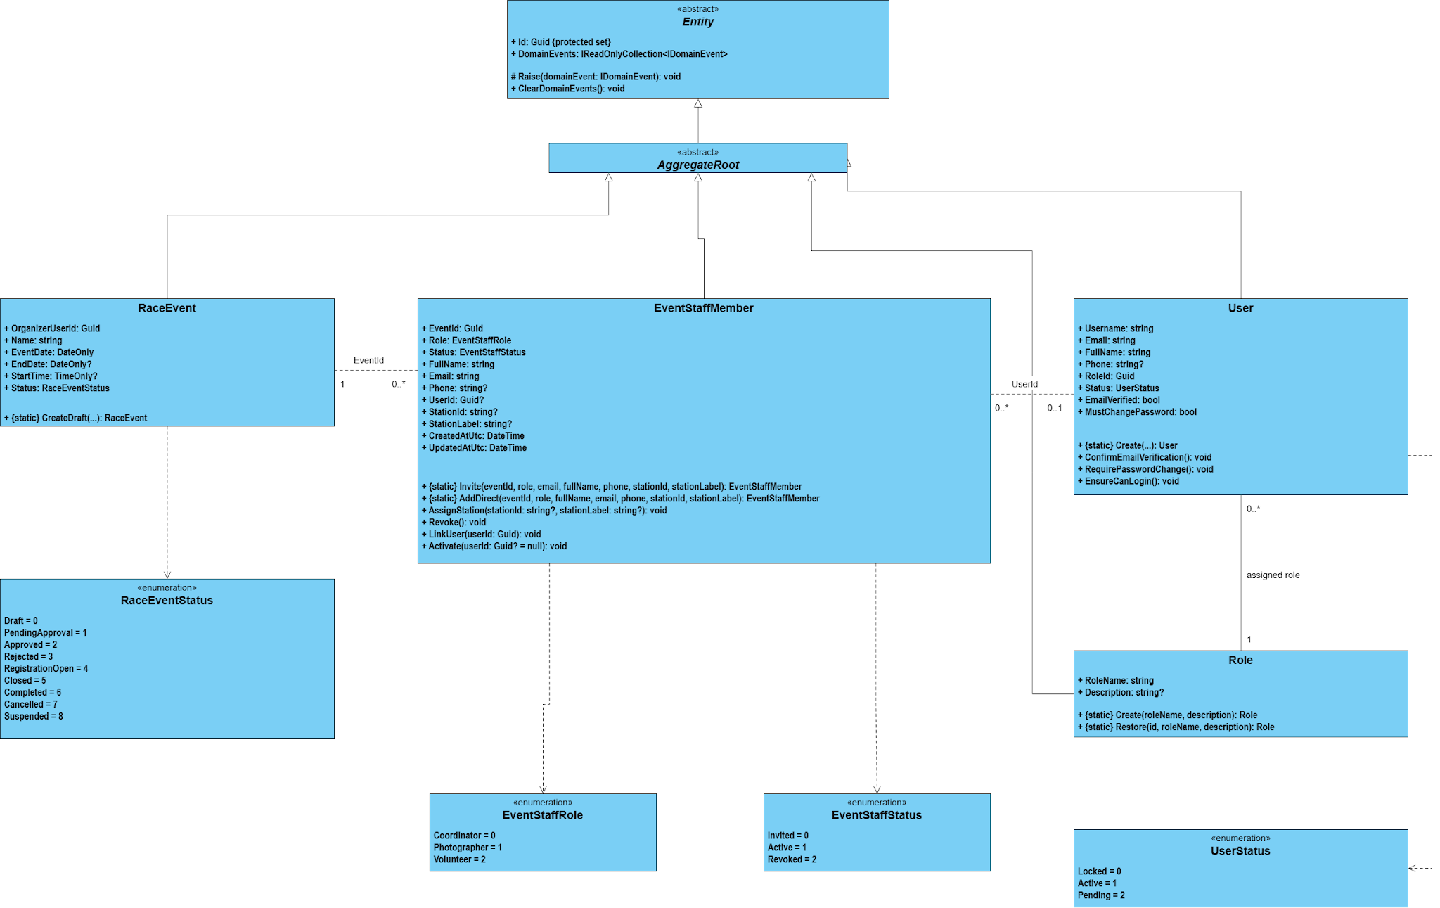
Figure 3.9.1

3.9.2 Sequence diagram:Create Event Staff Account
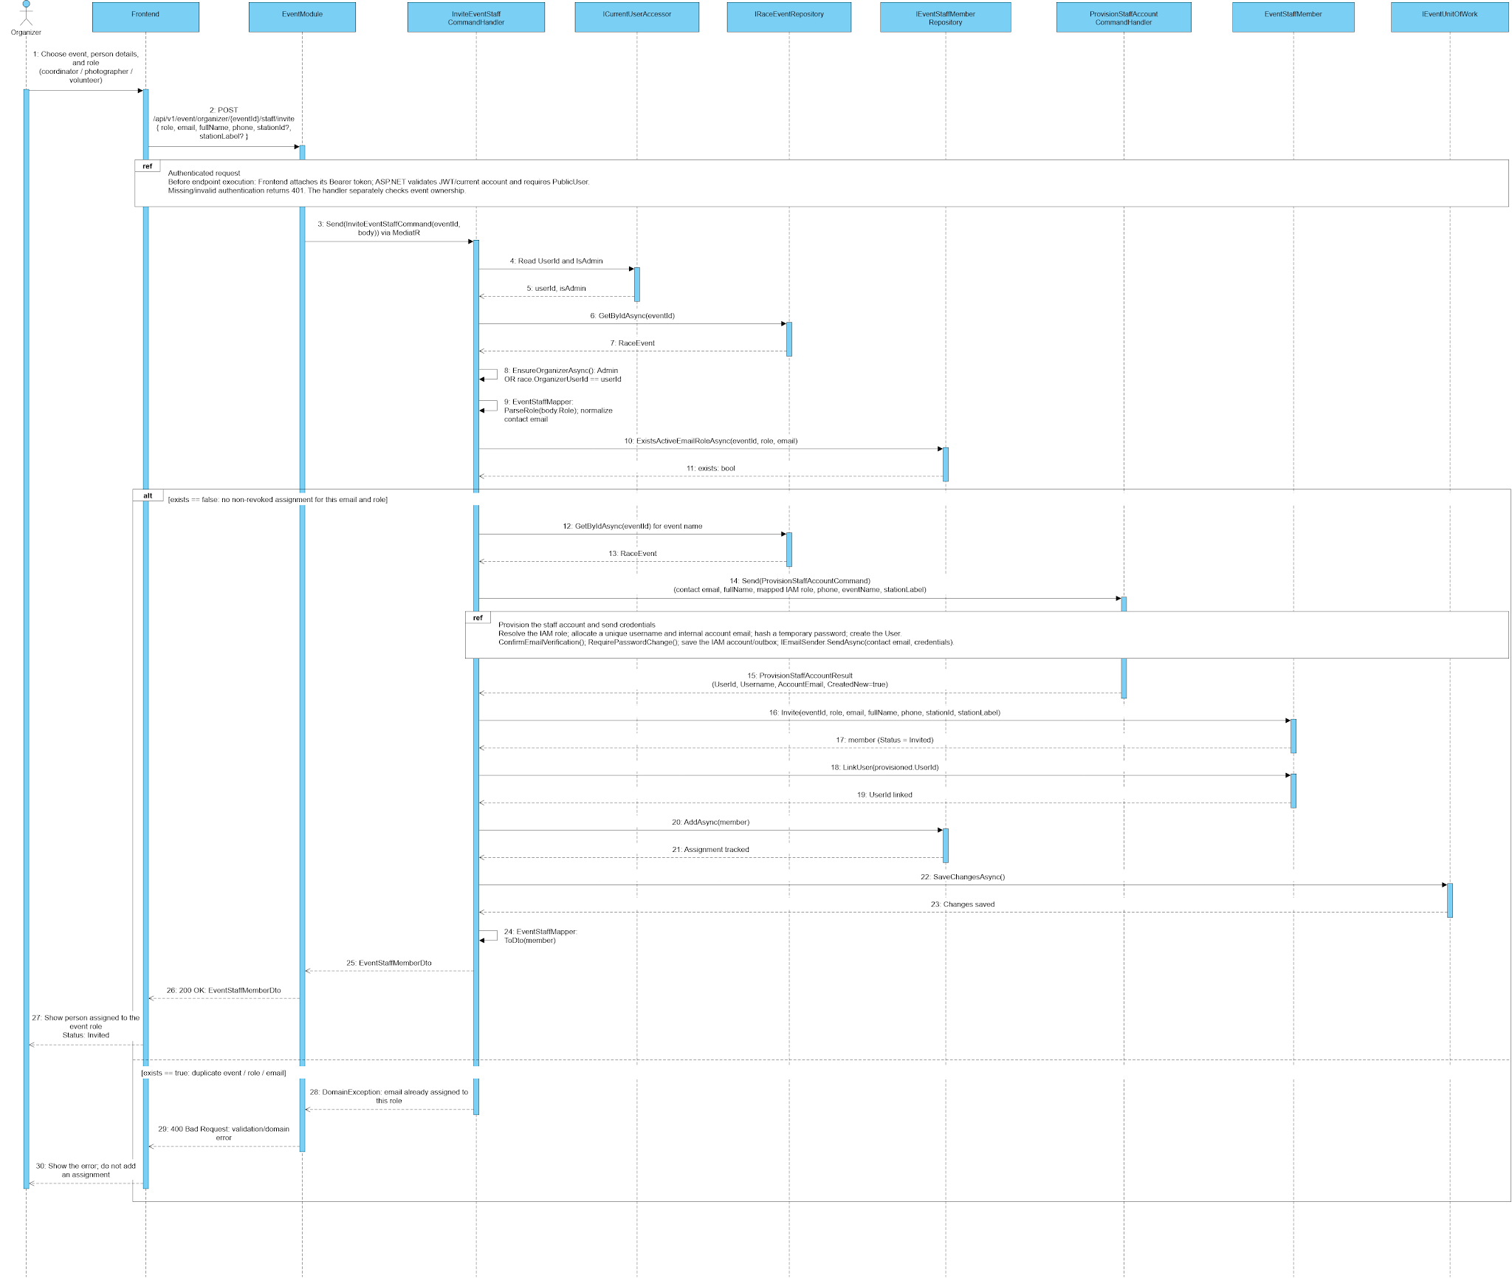
Figure 3.9.2

3.10 Platform Administration

3.10.1 Class Diagram
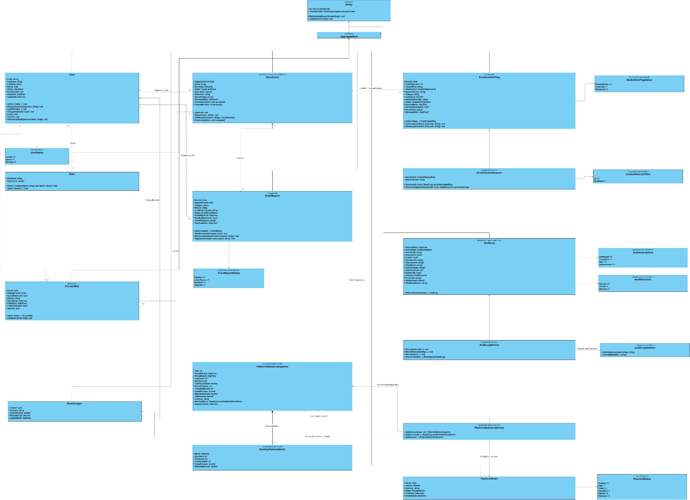
Figure 3.10.1

3.10.2 Sequence diagram:Approve Organizer
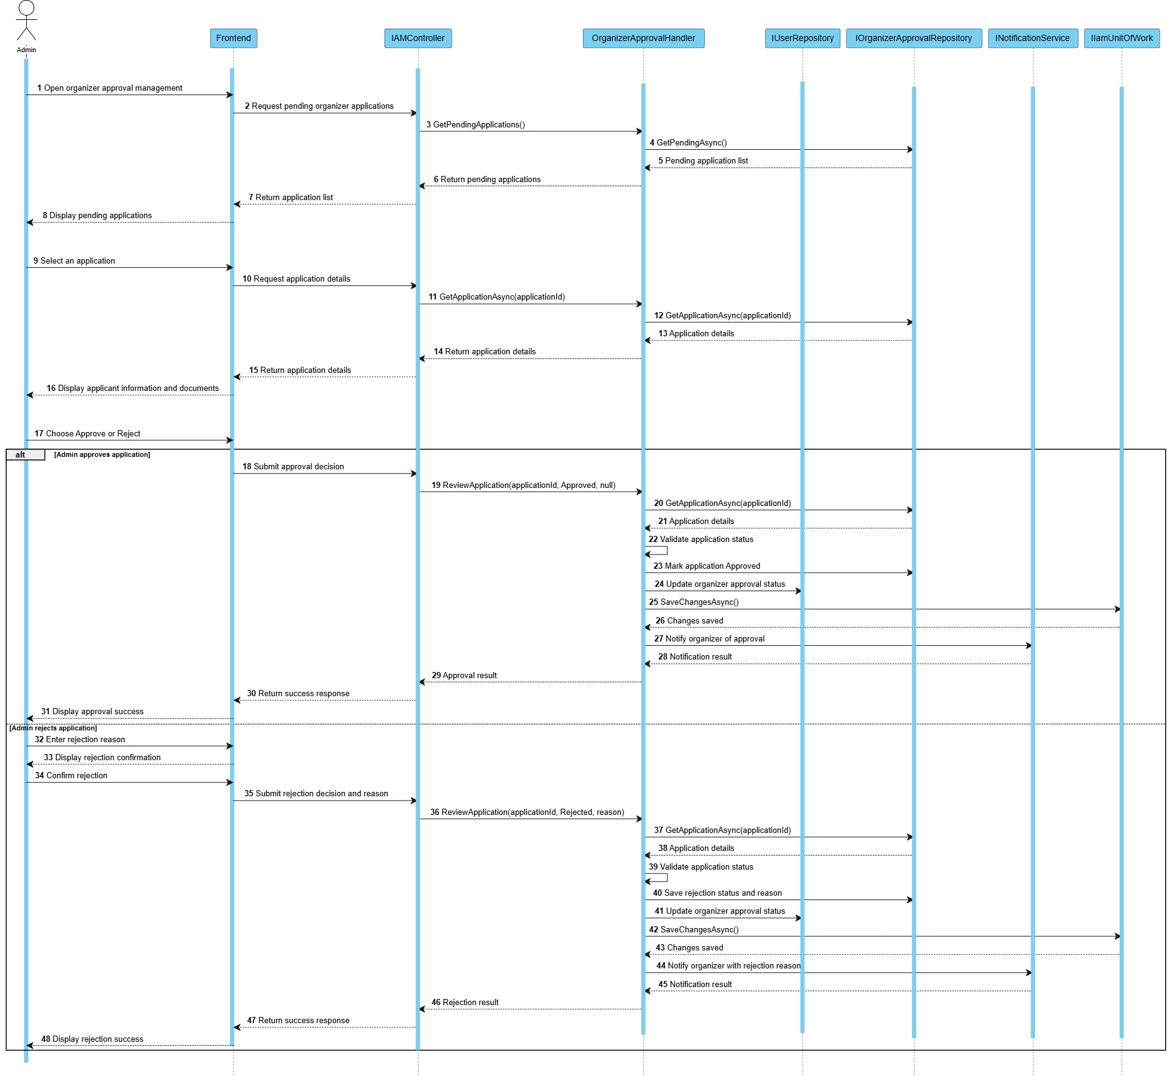
Figure 3.10.2

3.10.3 Sequence diagram:Approve Event
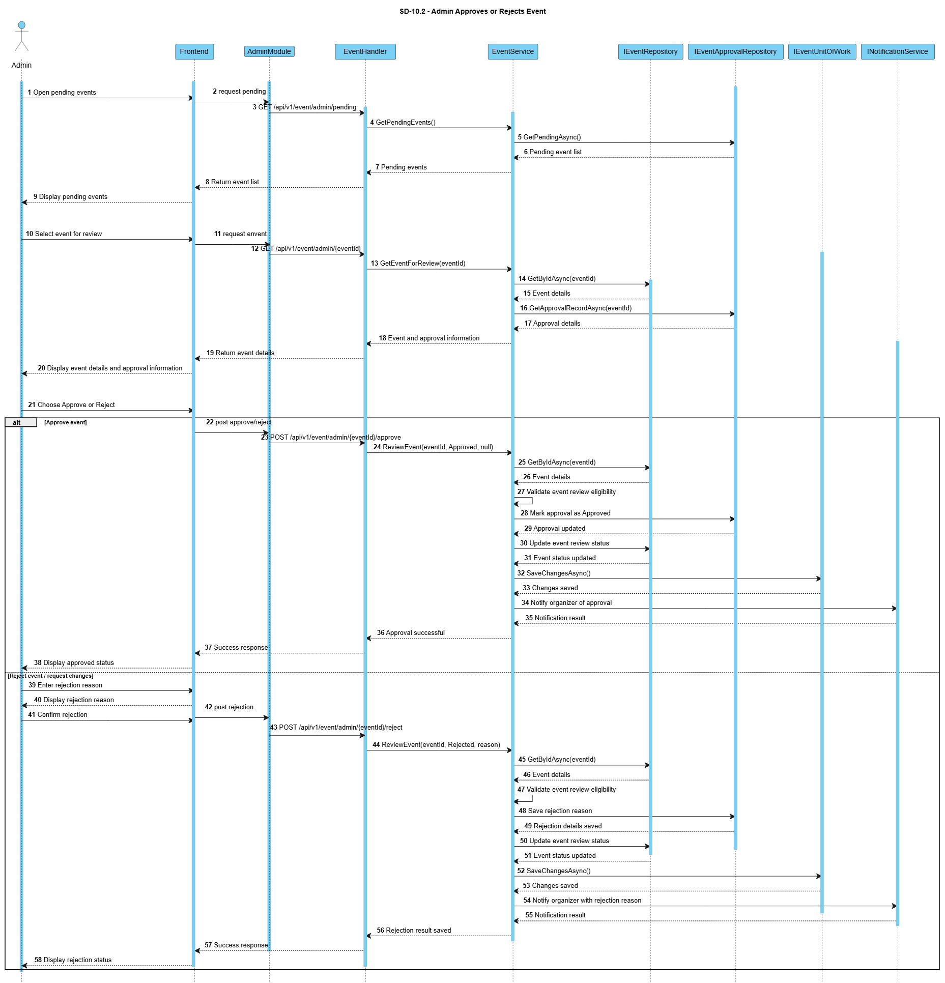
Figure 3.10.3

3.10.4 Sequence diagram:Publish Event
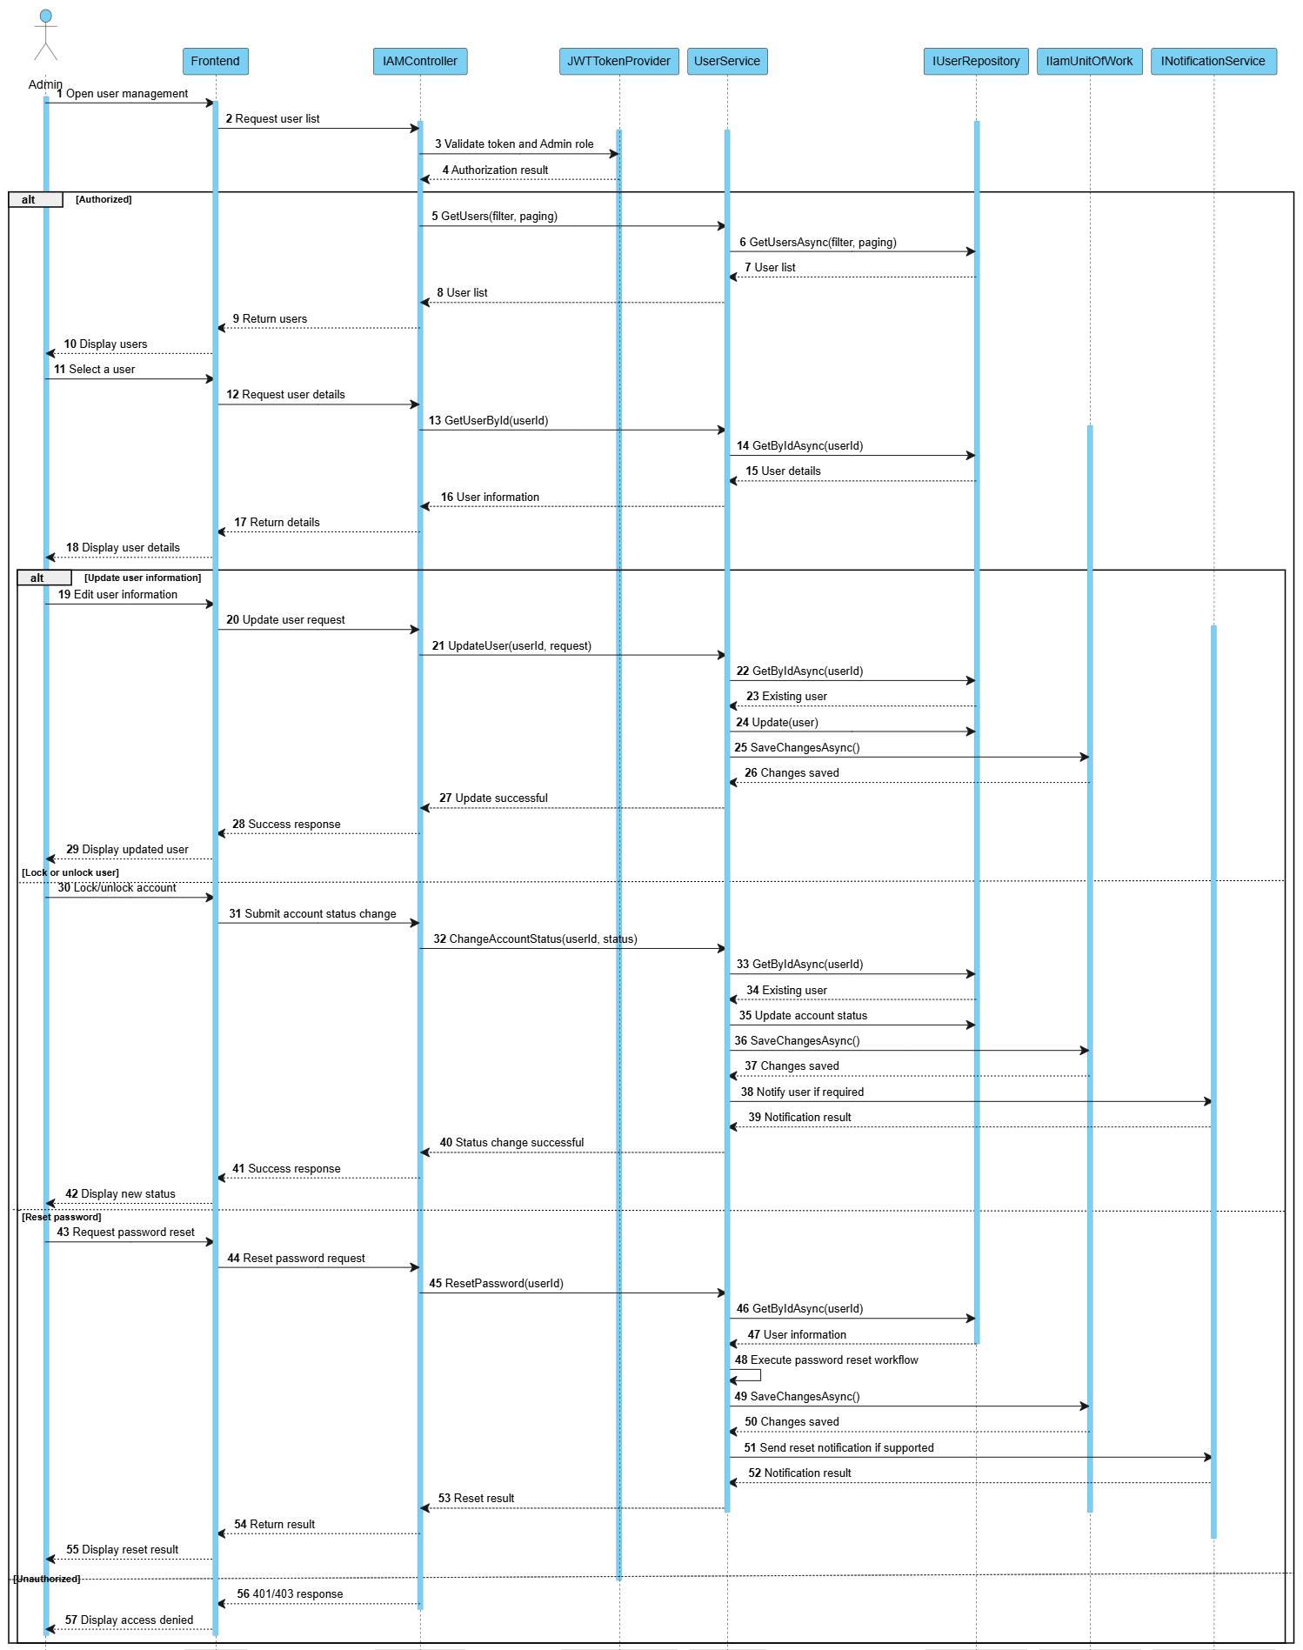Figure3.10.4

